

**ON-THE-JOB TRAINING NARRATIVE REPORT**

Presented to the

**COLLEGE OF INFORMATICS AND COMPUTING SCIENCES**

**BATANGAS STATE UNIVERSITY**

The National Engineering University

Lipa Campus

Marawoy, Lipa City

In Partial Fulfillment of the Requirements for the Degree

**BACHELOR OF INFORMATION TECHNOLOGY**

**MAJOR IN-SERVICE MANAGEMENT**



**TIPAN, SAVIOR ALLEN M.**

FEBRUARY 2025

**TABLE OF CONTENTS**

Page

TITLE PAGE1

TABLE OF CONTENTS **2**

**OVERVIEW OF THE OJT PROGRAM 3**

Background

Objective

Purpose of the Report

**COMPANY PROFILE**

Brief History

Organizational Structure

Products and Services Offered

Work Culture and Environment

**ON- THE-JOB TRAINING EXPERIENCE**

Job Description and Responsibilities

Task and Project Assigned

Challenges Encountered

Skills and knowledge Gained

Feedback and Evaluation from training Supervisor

**REFLECTION AND ANALYSIS**

Personal Goals and learning Objectives Achieved

Lessons Learned and Areas for Improvement

Relevance of the On-the-Job Training to Academic and Career Goals

Recommendations for Future Trainees

**CONCLUSION**

Summary of the On-the-Job Training Experience

Significance of the Program to Academic and Career Development

Acknowledgement of the Company and Training Supervisor

Gratitude to the University and Program Coordinators

**APPENDICES**

Pre-OJT Requirements

Post- OJT Requirements

**OVERVIEW OF THE ON-THE-JOB TRAINING PROGRAM**

This section presents the background, objectives and purpose of the report.

**BACKGROUND**

The university On-the-job training program has been a popular initiative for many years providing students with valuable experience in their chosen fields of study. The program was first introduced in early 20th century as a way of bridge the gap between academic learning and practical application.

Initially, the program was designed to provide students with an opportunity to give hands-on experience in their field of study while still attending university this allowed them to apply what they had learned in the classroom to real world situations in the well of important skills that would be essential for their future careers.

Over time the program evolved and become more structured, with universities partnering with business and organization to provide students with internship and other work-based learning opportunities. Today, the University On-the-job Training Program is the integral part of many degree programs offering students a chance to gain personal experience and make valuable connection in their industry.

Overall, the University On-the-job training program has proven to be an effective way of students to enhance their education and prefer for successful careers after graduation

**Objectives**

The objectives of the university on-the-job training program are the to provide students with practical experience to their chosen field of study, to enhance their skills and knowledge and to prepare them for workforce. As an intern, I believe that the program will help me achieve my career goals very giving we hands on experience in my field of interest.

As an intern at the Municipal Government of Mataas na Kahoy, I hope to gain invaluable practical experience by contributing to the development of an essential website that manages employee database records. I am excited to apply the theoretical knowledge from my academic studies to solve real-world challenges in web development and database management. I anticipate that each technical obstacle will serve as a learning opportunity to refine my coding, design, and problem-solving skills. I look forward to working on a project that directly impacts the efficiency of government operations. This hands-on experience will build my confidence and prepare me for the professional demands of the tech industry.

Through this program, I hope to enhance my technical competencies while also developing strong teamwork and communication skills. I am eager to collaborate with experienced professionals and mentors who can provide insights into best practices and industry standards. Working on the employee records system will help me understand the complexities of data privacy, user experience, and secure information handling. I aim to learn how to balance functionality with accessibility to ensure that the final product meets both technical and administrative requirements. This collaborative environment will allow me to strive academic learning with practical applications, making me a more well-rounded developer.

Finally, I hope that this on-the-job training will be a stepping stone toward achieving my long-term career goals. I plan to leverage the experience gained from this project to understand the inner workings of government technology systems and public service enhancements. I am enthusiastic about the prospect of receiving constructive feedback that will drive my personal and professional growth. I also look forward to mastering project management and time management skills in a real-world setting. Ultimately, this program will equip me with the necessary tools and confidence to excel in my future career in technology and public service.

**PURPOSE OF THE REPORT**

The purpose of the report is to document and communicate the OJT experience of the trainee. On-the-job training (OJT) is a crucial aspect of learning for any individual seeking to gain practical skills in their field of study. The report serves as a record of the trainee’s progress, highlighting their strengths and weaknesses, and provided feedback on areas that need improvement.

The purpose of this report is to document and communicate my on-the-job training (OJT) experience at the Municipal Government of Mataas na Kahoy. This report serves as a comprehensive record of my progress, detailing the tasks performed, skills learned, challenges encountered, and achievements accomplished during my training. It is designed to provide insight into my developmental journey and offer constructive feedback on areas requiring further improvement. Through careful documentation, I aim to reflect on my experiences and highlight the practical knowledge gained in a real-world environment. Overall, this report will serve as both a personal reflection and an official record of my contributions and learning during the training period.

My OJT took place at the Human Resources Department of the Municipal Government of Mataas na Kahoy, located at Municipal Hall Building, Victor Templo Avenue, National Highway, Mataas na Kahoy City, 4223. Under the guidance of our supervisor, Mr. Gally D. Tipan, I was involved in the development of a website designed to manage and track employee records. The tasks I performed ranged from initial system planning and design to hands-on coding and database management. I was actively involved in testing, troubleshooting, and ensuring the website met the operational requirements of the municipal HR department. This practical involvement provided me with a detailed understanding of how digital solutions can streamline administrative processes in a government setting.

Throughout my training, I acquired a wide range of skills that have significantly contributed to my professional growth. I enhanced my technical proficiency in web development, learning various coding languages and database management techniques. In addition, I developed problem-solving skills as I tackled the challenges of integrating multiple system components into a cohesive website. I also learned the importance of user interface design and user experience to ensure that the system is accessible and efficient for all HR staff members. Moreover, my communication and teamwork abilities improved as I collaborated closely with colleagues and received regular guidance from Mr. Tipan.

The journey was not without its challenges, and I encountered several obstacles along the way. One of the primary challenges was adapting to the fast-paced environment of a government institution where the pace of technological updates and administrative demands often conflicted. I faced technical hurdles such as debugging complex code issues and ensuring the security of sensitive employee data. Balancing academic knowledge with practical implementation also proved to be a learning curve, particularly when dealing with unexpected system errors. However, each challenge provided a valuable lesson that enhanced my resilience and adaptability in the professional world.

In conclusion, my OJT experience at the Municipal Government of Mataas na Kahoy has been a stepping stone in my career development. I successfully contributed to the development of a critical website that improved the efficiency of tracking employee records, thereby making a tangible impact on the municipality's operations. The achievements during this training have not only boosted my technical skills but have also strengthened my problem-solving and collaborative capabilities. The practical insights gained from overcoming challenges have prepared me for future professional endeavors in the field of technology. This report encapsulates the valuable lessons learned, and I am confident that the experience will significantly influence my future career path.

**COMPANY PROFILE**

**Brief History**

There was once a widow who lived in a small barrio. She had two sons living with her in a nipa hut. One day the old woman became ill. She had taken many medicines, but she would not get well. One night she dreamt of a fruit that could cure her. The next morning, she related her dream to her sons. The two boys left to look for the fruit. After a long search, they reached the place, where they saw a very tall tree. The boys stopped, and they started looking for the fruit. Where they found the fruit at the top of the tree. The older boy started to climb the tall tree.

   When he was halfway up the tree the younger boy cried, “Be careful, you might fall, the tree is very tall.” The older brother replied, “I have to climb this tall tree to get the fruit for the mother’s sake.” And so, he got the fruit.

  The two boys hurried home with the fruit and gave the fruit to their mother. She ate the fruit and like a miracle, the mother got well. From that time on the place where the tall tree was found has been called Mataasnakahoy.

The name “Mataasnakahoy” was registered as a barrio of the Municipality of Lipa in 1878. It was specified in the Executive Order that the new Municipality would embrace all of the territories comprising the two barrios of Calingatan and Mataasnakahoy.  
Mataasnakahoy was sliced out of the northwestern part of the then Municipality of Lipa. The town takes the shape of a triangle with one of the three sides bordering the shore of Taal Lake.  The whole place is hilly.  Only one of the three corners is level, where the Poblacion lies. It was declared as an independent Municipality on March 1932 by virtue of EO No. 308 by the acting Governor-General George C. Butte.

​LGUMataasnakahoy

**University Vision**

A world-class agro-ecotourism destination, God-loving, participative, empowered, and globally competitive citizenry, living in a safe and ecologically balanced environment guided by committed and responsible leaders.

**University Mission**

 To ensure a God-centered society and strengthen agro-ecotourism industry by seeking dynamic investment opportunities and continuously preserving a conducive climate for socio-political, cultural, ecological, and economic development through committed partnership with public, private sector, and civil society organizations

**Organizational Structure**

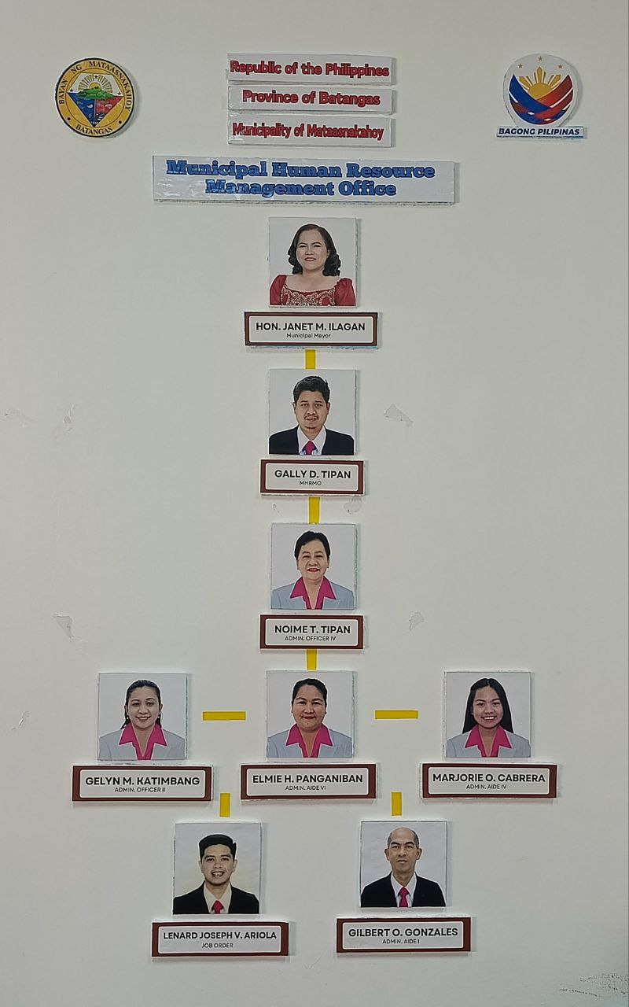

**Products and Services Offered**

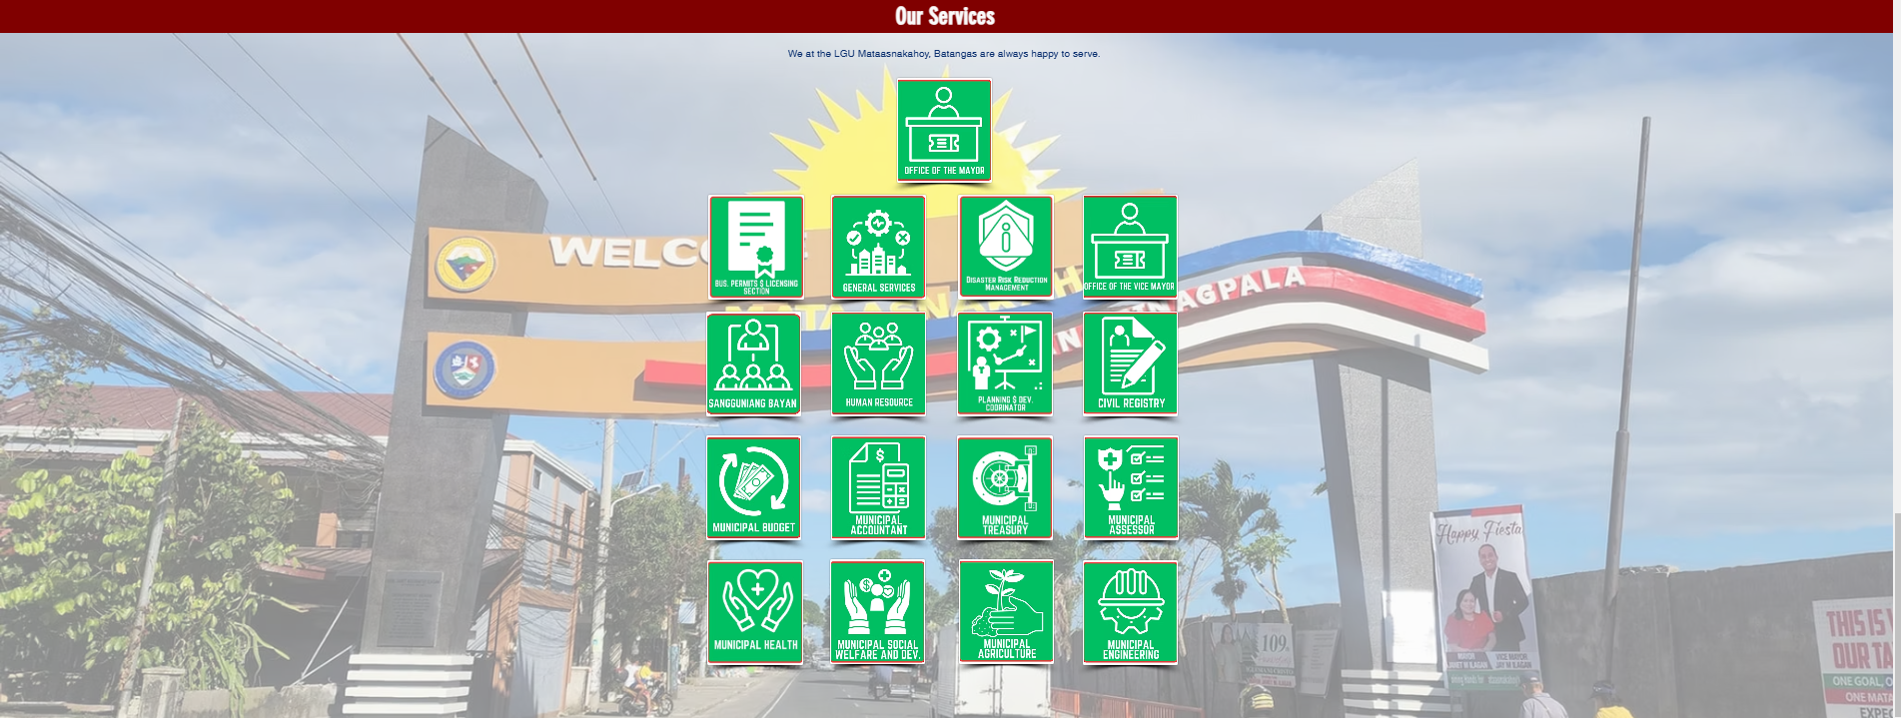

**Work Culture and Environment**

The work culture at the Municipal Government of Mataas na Kahoy was both professional and welcoming. Despite being an intern, I was treated as a valuable member of the team, with my ideas and contributions being acknowledged and appreciated. My supervisor, Mr. Gally D. Tipan, provided guidance and constructive feedback, ensuring that I understood my tasks and responsibilities. The HR Department staff were accommodating and supportive, always ready to assist me whenever I encountered difficulties. Working in a government office also exposed me to a structured and formal work environment, where processes and protocols were strictly followed to maintain efficiency and order.

The environment encouraged collaboration and continuous learning. I had the opportunity to work with experienced professionals who willingly shared their expertise and best practices in IT and administrative work. Although deadlines and technical challenges occasionally created pressure, the supportive atmosphere helped me stay motivated and focused. The experience taught me the importance of adaptability, teamwork, and professionalism in a real-world work setting, which I believe will be beneficial in my future career endeavors.

**OJT TRAINING EXPERIENCE**

**Job Description and Responsibilities**

As an intern at the Municipal Government of Mataas na Kahoy under the HR Department, my primary responsibility was to assist in developing a website for managing employee database records. This website aimed to streamline employee record-keeping, making it easier for HR personnel to track and retrieve necessary documents when requested. My tasks included designing the website’s user interface, ensuring a seamless user experience, and implementing backend functionalities to store and manage employee information securely. I was also involved in troubleshooting technical issues related to the software and hardware used in the office, such as desktops, laptops, and network connectivity.

Additionally, I played a role in configuring and installing operating systems, software applications, and security measures to safeguard sensitive employee data. I worked closely with my supervisor and HR personnel to gather requirements, test website features, and ensure compliance with data privacy policies. Beyond web development, I also assisted in maintaining and managing user accounts and permissions. This hands-on experience provided me with a deeper understanding of the responsibilities of an IT professional in a government setting.

**Task and Projects Assigned**

Task and projects are assigned to trainees to help them develop the skills and knowledge needed for their job. These Assignments provide practical experience and allow trainees to apply what they learned in a real-world setting

**Week 1**

**( June 7- June 9, 2024 ) Example Date**

Image of Trainee attending Assigned Task

Image of Trainee attending Assigned Task

Image of Trainee attending Assigned Task

Image

Image

Image

*( Narration of the assigned task for the week)*

***Reminder weekly po ito kung ilang weeks kayo yon din yon bilang na gagawin yong task and project assigned same with RLE***

**Week 1**

**(February 17– February 21, 2025)**

During my first week, I focused on orientation and initial setup. I met with the HR staff and discussed my OJT scope and responsibilities. I set up my local development environment using XAMPP/VS Code, which allowed me to start working on the employee records website. I also drafted initial wireframes for the site, researched data privacy guidelines, and designed the preliminary database for storing employee information. By the end of the week, I had familiarized myself with the project and documented my progress for my supervisor.

**Week 2**

**(February 24– February 28, 2025)**

In week 2, I improved the database structure based on feedback from HR. I began coding the CRUD operations for employee records and added form validations for new entries. I also worked on making the site responsive for PC views, ensuring that the design adapts smoothly across the department devices. Additionally, I concluded the week by summarizing my accomplishments in a detailed report.

**Week 3**

**(March 3– March 7, 2025)**

This week, I concentrated on enhancing user authentication and security. I integrated a password reset feature and developed role-based access control for HR staff and administrators. I also optimized SQL queries to ensure faster page loading and created user-friendly forms for editing employee profiles. Furthermore, I implemented session management to handle timeouts and automatic logouts. I rounded off the week by participating in a code review session with fellow interns and updating my progress report.

**Week 4**

**(March 10– March 14, 2025)**

In week 4, I worked on enhancing the website’s search functionality and data handling. I implemented search filters by name and department and collaborated with HR to refine these options. I gathered some valuable UI/UX feedback. Alongside this, I enhanced the database indexing for faster queries and learned more about government regulations on electronic record storage. I finished by creating backup and restore procedures and summarizing my key learnings.

**Week 5**

**(March 17– March 21, 2025)**

During week 5, I expanded the system’s features by adding a dashboard overview that displayed employee statistics and new hires. I implemented department-level access for managers and reviewed the security of my forms against SQL injection attacks. I also debugged issues related to session timeouts and optimized website performance by applying caching and minification techniques. In addition, I developed an analytics page to visualize employee distribution by department and presented a mid-project demo to the HR team. My weekly report highlighted the feedback I received and the changes I planned for the next phase.

**Week 6**

**(March 24– March 28, 2025)**

In week 6, my focus shifted to data reporting and audit trails. I refined the dashboard UI by enhancing charts and graphs for clearer data visualization. I created custom PDF reports for employee data and implemented an audit trail to track user edits with timestamps. I tested the website’s responsiveness across multiple devices and made improvements based on HR feedback. By the end of the week, I had deployed updated modules to a staging server for further review.

**Week 7**

**(March 31–April 4, 2025)**

During week 7, I worked on finalizing the website’s design and preparing user interface. I applied a professional, municipal-branded style by confirming color schemes and logos with the HR department. I migrated test employee data into the system and began drafting user manuals for the HR staff. I also troubleshooted display issues on older browsers and performed load testing to ensure the site could handle multiple users simultaneously. I documented all final revisions and summarized my daily tasks for the week.

**Week 8**

**(April 7– April 11, 2025)**

This week, I focused on adding advanced functionality to the website. I implemented advanced search filters, such as filtering by date of hire and position, and ensured the system complied with data privacy rules. I also introduced pagination for large data sets and coordinated with HR to verify that the migrated records were accurate. I conducted thorough security testing (including SQL injection and XSS) and patched any vulnerabilities found. I updated all related documentation and laid out the steps for the upcoming soft launch.

**Week 9**

**(April 14– April 16, 2025)**

In this shortened week, I ran user acceptance testing with a small HR group, focusing on navigation and overall user experience. I implemented interface improvements, such as clearer buttons and relabeled menus, and updated the training materials accordingly. I finalized data backup processes and prepared a partial rollout plan to ensure a smooth transition when the system goes live. I also documented my readiness for the soft launch and reviewed the feedback received during testing.

**Week 10**

**(April 21– April 25, 2025)**

During week 10, I deployed the system for initial real-time use by the HR staff. I closely monitored system performance and collected immediate feedback from the user. I fixed minor bugs related to search filters and layout tweaks, and I conducted follow-up training sessions with HR user. I enhanced the reporting features by adding custom date ranges and updated the style guidelines to prepare for the official launch. I also performed stress tests to ensure the system’s reliability under heavy use.

**Week 11**

**(April 28–May 2, 2025)**

In week 11, I reviewed the final content to ensure that all employee records and departmental information were accurate. I integrated user feedback forms to gather ongoing suggestions and troubleshot issues with email notifications for password resets. I created a tutorial to help HR staff navigate the new system and coordinated with IT support for a smooth handover. I monitored system logs for any performance issues and finalized the training schedule for the remaining staff. My detailed weekly report summarized all these activities.

**Week 12**

**(May 5– May 9, 2025)**

During week 12, I expanded the website’s access to a broader group of municipal employees and collected feedback on loading times and overall interface clarity. I fixed layout inconsistencies across different browsers and conducted training sessions on generating custom reports. I updated the user manuals with the latest screenshots and made improvements based on feedback. I also investigated slow queries, implementing indexing and caching to improve performance. I documented best practices for future developers and compiled all bug reports for a final review.

**Week 13**

**(May 13– May 16, 2025)**

In week 13, I conducted a final run-through of all system modules and resolved last-minute bugs related to password resets and user roles. I updated the system documentation to reflect all final interface changes and worked with my supervisor to schedule the official launch date. I assisted HR staff with any remaining data migration issues and created guidelines for ongoing backups and maintenance. I prepared a final presentation for the Municipal Government and consolidated all project files for handover.

**Week 14**

**(May 19– May 20, 2025)**

In my final week, I officially launched the website for daily HR use and closely monitored its stability and user feedback. I finalized all OJT documentation and reports, ensuring that every detail of the development process was captured. I conducted an exit meeting with my supervisor to discuss my overall performance, key learnings, and post-deployment maintenance plans. This final phase marked the culmination of my 600-hour practical experience, where I successfully applied my skills in a real-world setting.

Name of Student-Trainee : **SAVIOR ALLEN M. TIPAN**

Course : **BSIT SERVICE MANAGEMENT**

Name of Company : **MUNICIPAL GOVERNMENT OF MATAAS NA KAHOY**

Department : **HR DEPARTMENT**

Company Address : **MUNICIPAL HALL BUILDING VICTOR TEMPLO AVE.**

**NATIONAL HIGHWAY, MATAAS NA KAHOY**

**RELATED LEARNING EXPERIENCE**

Week 1

|  |  |  |
| --- | --- | --- |
| **DATE**  **DAY** | **TASKS** | **NO. OF HOURS RENDERED** |
| February 17, 2025 Monday | * Orientation with HR staff; discussed OJT scope and responsibilities * Set up local development environment (XAMPP/VS Code) | 8 |
| February 18, 2025 Tuesday | * Drafted initial description for the employee records website * Conducted research on data privacy and government standards | 8 |
| February 19, 2025 Wednesday | * Designed database schema for storing employee information * Started coding the front-end layout using HTML and CSS | 8 |
| February 20, 2025 Thursday | * Implemented basic user login/logout functionality * Discussed potential security measures (encryption, role-based access) | 8 |
| February 21, 2025 Friday | * Tested initial modules; documented minor bugs * Prepared weekly progress report for supervisor | 8 |
| **Total** | | **40 hours** |

Prepared by:

**SAVIOR ALLEN M. TIPAN**

Student-Trainee

Noted:

**Mr. GALLY D. TIPAN Mr. Dioneces O. Alimoren**

HR Supervisor OJT Coordinator, CICS

Name of Student-Trainee : **SAVIOR ALLEN M. TIPAN**

Course : **BSIT SERVICE MANAGEMENT**

Name of Company : **MUNICIPAL GOVERNMENT OF MATAAS NA KAHOY**

Department : **HR DEPARTMENT**

Company Address : **MUNICIPAL HALL BUILDING VICTOR TEMPLO AVE.**

**NATIONAL HIGHWAY, MATAAS NA KAHOY**

**RELATED LEARNING EXPERIENCE**

Week 2

|  |  |  |
| --- | --- | --- |
| **DATE**  **DAY** | **TASKS** | **NO. OF HOURS RENDERED** |
| Feb 24, 2025  Monday | * Improved database structure based on HR feedback * Began coding CRUD (Create, Read, Update, Delete) for employee records | 8 |
| Feb 25, 2025  Tuesday | * Added form validations for new employee entries * Coordinated with HR to finalize required data fields | 8 |
| Feb 26, 2025 Wednesday | * Implemented responsive design for PC views * Researched government guidelines for secure data handling | 8 |
| Feb 27, 2025 Thursday | * Conducted initial usability testing with selected HR staff * Documented interface improvements based on feedback | 8 |
| Feb 28, 2025 Friday | * Troubleshoot minor layout bugs; refined site * Prepared weekly summary of accomplishments | 8 |
| **Total** | | **40 hours** |

Prepared by:

**SAVIOR ALLEN M. TIPAN**

Student-Trainee

Noted:

**Mr. GALLY D. TIPAN Mr. Dioneces O. Alimoren**

HR Supervisor OJT Coordinator, CICS

Name of Student-Trainee : **SAVIOR ALLEN M. TIPAN**

Course : **BSIT SERVICE MANAGEMENT**

Name of Company : **MUNICIPAL GOVERNMENT OF MATAAS NA KAHOY**

Department : **HR DEPARTMENT**

Company Address : **MUNICIPAL HALL BUILDING VICTOR TEMPLO AVE.**

**NATIONAL HIGHWAY, MATAAS NA KAHOY**

**RELATED LEARNING EXPERIENCE**

Week 3

|  |  |  |
| --- | --- | --- |
| **DATE**  **DAY** | **TASKS** | **NO. OF HOURS RENDERED** |
| Mar 3, 2025  Monday | * Integrated password reset functionality * Reviewed best practices for encryption and secure authentication | 8 |
| Mar 4, 2025  Tuesday | * Developed role-based access (HR staff, admin) * Optimized SQL queries for faster page loading | 8 |
| Mar 5, 2025 Wednesday | * Created user-friendly forms for editing employee profiles * Began implementing session management (login, logout) | 8 |
| Mar 6, 2025  Thursday | * Conducted code reviews with fellow interns * Documented coding standards for consistency | 8 |
| Mar 7, 2025  Friday | * Deployed updates to a test server for internal review * Generated weekly progress report | 8 |
| **Total** | | **40 hours** |

Prepared by:

**SAVIOR ALLEN M. TIPAN**

Student-Trainee

Noted:

**Mr. GALLY D. TIPAN Mr. Dioneces O. Alimoren**

HR Supervisor OJT Coordinator, CICS

Name of Student-Trainee : **SAVIOR ALLEN M. TIPAN**

Course : **BSIT SERVICE MANAGEMENT**

Name of Company : **MUNICIPAL GOVERNMENT OF MATAAS NA KAHOY**

Department : **HR DEPARTMENT**

Company Address : **MUNICIPAL HALL BUILDING VICTOR TEMPLO AVE.**

**NATIONAL HIGHWAY, MATAAS NA KAHOY**

**RELATED LEARNING EXPERIENCE**

Week 4

|  |  |  |
| --- | --- | --- |
| **DATE**  **DAY** | **TASKS** | **NO. OF HOURS RENDERED** |
| Mar 10, 2025  Monday | * Implemented search functionality (by name, department, etc.) * Collaborated with HR on advanced search filters | 8 |
| Mar 11, 2025  Tuesday | * Improved form validation (real-time error messages) * Assisted in troubleshooting session management bugs | 8 |
| Mar 12, 2025 Wednesday | * Conducted user acceptance testing with a HR supervisor * Gathered feedback for UI/UX improvements | 8 |
| Mar 13, 2025 Thursday | * Enhanced database indexing for faster queries * Studied local government regulations on electronic record storage | 8 |
| Mar 14, 2025  Friday | * Created backup and restore procedures for the database * Summarized key learnings for weekly review | 8 |
| **Total** | | **40 hours** |

Prepared by:

**SAVIOR ALLEN M. TIPAN**

Student-Trainee

Noted:

**Mr. GALLY D. TIPAN Mr. Dioneces O. Alimoren**

HR Supervisor OJT Coordinator, CICS

Name of Student-Trainee : **SAVIOR ALLEN M. TIPAN**

Course : **BSIT SERVICE MANAGEMENT**

Name of Company : **MUNICIPAL GOVERNMENT OF MATAAS NA KAHOY**

Department : **HR DEPARTMENT**

Company Address : **MUNICIPAL HALL BUILDING VICTOR TEMPLO AVE.**

**NATIONAL HIGHWAY, MATAAS NA KAHOY**

**RELATED LEARNING EXPERIENCE**

Week 5

|  |  |  |
| --- | --- | --- |
| **DATE**  **DAY** | **TASKS** | **NO. OF HOURS RENDERED** |
| Mar 17, 2025  Monday | * Added a dashboard overview (employee stats, new hires) * Discussed future modules (leave management, performance reviews) | 8 |
| Mar 18, 2025  Tuesday | * Implemented department-level access for managers * Reviewed form security against attackers | 8 |
| Mar 19, 2025 Wednesday | * Debugged session timeouts and cookie handling * Optimized website performance (caching, minified scripts) | 8 |
| Mar 20, 2025 Thursday | * Created an analytics page (employee distribution by department) * Drafted guidelines on interpreting analytics data | 8 |
| Mar 21, 2025  Friday | * Presented mid-project demo to HR staff * Documented requested changes for next iteration | 8 |
| **Total** | | **40 hours** |

Prepared by:

**SAVIOR ALLEN M. TIPAN**

Student-Trainee

Noted:

**Mr. GALLY D. TIPAN Mr. Dioneces O. Alimoren**

HR Supervisor OJT Coordinator, CICS

Name of Student-Trainee : **SAVIOR ALLEN M. TIPAN**

Course : **BSIT SERVICE MANAGEMENT**

Name of Company : **MUNICIPAL GOVERNMENT OF MATAAS NA KAHOY**

Department : **HR DEPARTMENT**

Company Address : **MUNICIPAL HALL BUILDING VICTOR TEMPLO AVE.**

**NATIONAL HIGHWAY, MATAAS NA KAHOY**

**RELATED LEARNING EXPERIENCE**

Week 6

|  |  |  |
| --- | --- | --- |
| **DATE**  **DAY** | **TASKS** | **NO. OF HOURS RENDERED** |
| Mar 24, 2025  Monday | * Refined dashboard UI; improved charts and graphs * Tested website responsiveness for PC viewing | 8 |
| Mar 25, 2025  Tuesday | * Addressed bugs related to data filtering in analytics * Collaborated with colleagues to maintain coding standards | 8 |
| Mar 26, 2025 Wednesday | * Created custom PDF reports for employee data * Ensured compatibility with various PDF libraries | 8 |
| Mar 27, 2025 Thursday | * Implemented audit trail (tracking user edits, timestamps) * Reviewed logging best practices for compliance | 8 |
| Mar 28, 2025  Friday | * Deployed latest updates to a staging server * Collected feedback from HR staff on performance and usability | 8 |
| **Total** | | **40 hours** |

Prepared by:

**SAVIOR ALLEN M. TIPAN**

Student-Trainee

Noted:

**Mr. GALLY D. TIPAN Mr. Dioneces O. Alimoren**

HR Supervisor OJT Coordinator, CICS

Name of Student-Trainee : **SAVIOR ALLEN M. TIPAN**

Course : **BSIT SERVICE MANAGEMENT**

Name of Company : **MUNICIPAL GOVERNMENT OF MATAAS NA KAHOY**

Department : **HR DEPARTMENT**

Company Address : **MUNICIPAL HALL BUILDING VICTOR TEMPLO AVE.**

**NATIONAL HIGHWAY, MATAAS NA KAHOY**

**RELATED LEARNING EXPERIENCE**

Week 7

|  |  |  |
| --- | --- | --- |
| **DATE**  **DAY** | **TASKS** | **NO. OF HOURS RENDERED** |
| Mar 31, 2025  Monday | * Finalized styling for a professional, municipal-branded look * Confirmed color schemes and logos with HR department | 8 |
| April 1, 2025  Tuesday | * Migrated test employee data into the new system * Began drafting user manuals for HR staff | 8 |
| April 2, 2025 Wednesday | * Troubleshot minor display issues on older browsers * Enhanced accessibility (ALT tags, larger text options) | 8 |
| April 3, 2025  Thursday | * Performed load testing for concurrent user access * Optimized queries based on load test results | 8 |
| Apr 4, 2025  Friday | * Compiled staging site feedback; documented final revisions * Summarized daily tasks for weekly meeting | 8 |
| **Total** | | **40 hours** |

Prepared by:

**SAVIOR ALLEN M. TIPAN**

Student-Trainee

Noted:

**Mr. GALLY D. TIPAN Mr. Dioneces O. Alimoren**

HR Supervisor OJT Coordinator, CICS

Name of Student-Trainee : **SAVIOR ALLEN M. TIPAN**

Course : **BSIT SERVICE MANAGEMENT**

Name of Company : **MUNICIPAL GOVERNMENT OF MATAAS NA KAHOY**

Department : **HR DEPARTMENT**

Company Address : **MUNICIPAL HALL BUILDING VICTOR TEMPLO AVE.**

**NATIONAL HIGHWAY, MATAAS NA KAHOY**

**RELATED LEARNING EXPERIENCE**

Week 8

|  |  |  |
| --- | --- | --- |
| **DATE**  **DAY** | **TASKS** | **NO. OF HOURS RENDERED** |
| April 7, 2025  Monday | * Added advanced search filters (date of hire, position) * Reviewed system compliance with data privacy rules | 8 |
| April 8, 2025  Tuesday | * Implemented pagination for large data sets * Coordinated with HR to verify accuracy of migrated records | 8 |
| April 9, 2025 Wednesday | Holiday | - |
| April 10, 2025 Thursday | * Conducted security testing (password encryption) * Patched vulnerabilities found during tests | 8 |
| April 11, 2025  Friday | * Updated documentation to reflect new security measures * Planned steps for finalizing site before soft launch | 8 |
| **Total** | | **40 hours** |

Prepared by:

**SAVIOR ALLEN M. TIPAN**

Student-Trainee

Noted:

**Mr. GALLY D. TIPAN Mr. Dioneces O. Alimoren**

HR Supervisor OJT Coordinator, CICS

Name of Student-Trainee : **SAVIOR ALLEN M. TIPAN**

Course : **BSIT SERVICE MANAGEMENT**

Name of Company : **MUNICIPAL GOVERNMENT OF MATAAS NA KAHOY**

Department : **HR DEPARTMENT**

Company Address : **MUNICIPAL HALL BUILDING VICTOR TEMPLO AVE.**

**NATIONAL HIGHWAY, MATAAS NA KAHOY**

**RELATED LEARNING EXPERIENCE**

Week 9

|  |  |  |
| --- | --- | --- |
| **DATE**  **DAY** | **TASKS** | **NO. OF HOURS RENDERED** |
| April 14, 2025  Monday | * Conducted user acceptance testing with a small HR group * Collected feedback on navigation and user-friendliness | 8 |
| April 15, 2025 Tuesday | * Implemented improvements (clearer buttons, relabeled menus) * Updated training materials to match interface changes | 8 |
| April 16, 2025 Wednesday | * Finalized data backup processes; prepared partial rollout plan * Summarized readiness for soft launch | 8 |
| April 17, 2025 Thursday | Holiday | - |
| April 18, 2025  Friday | Holiday | - |
| **Total** | | **24 hours** |

Prepared by:

**SAVIOR ALLEN M. TIPAN**

Student-Trainee

Noted:

**Mr. GALLY D. TIPAN Mr. Dioneces O. Alimoren**

HR Supervisor OJT Coordinator, CICS

Name of Student-Trainee : **SAVIOR ALLEN M. TIPAN**

Course : **BSIT SERVICE MANAGEMENT**

Name of Company : **MUNICIPAL GOVERNMENT OF MATAAS NA KAHOY**

Department : **HR DEPARTMENT**

Company Address : **MUNICIPAL HALL BUILDING VICTOR TEMPLO AVE.**

**NATIONAL HIGHWAY, MATAAS NA KAHOY**

**RELATED LEARNING EXPERIENCE**

Week 10

|  |  |  |
| --- | --- | --- |
| **DATE**  **DAY** | **TASKS** | **NO. OF HOURS RENDERED** |
| April 21, 2025  Monday | * Deployed the system for initial real-time use by HR staff * Monitored performance and gathered immediate user feedback | 8 |
| April 22, 2025 Tuesday | * Fixed minor bugs reported (search filters, layout tweaks) * Conducted follow-up training for newly added HR users | 8 |
| Apr 23, 2025 Wednesday | * Enhanced reporting features (custom date ranges) * Analyzed user feedback for UI improvements | 8 |
| Apr 24, 2025 Thursday | * Updated style guidelines; refined color palette * Documented final changes for upcoming official launch | 8 |
| Apr 25, 2025  Friday | * Performed stress tests to ensure system reliability * Prepared weekly status report for HR supervisor | 8 |
| **Total** | | **24 hours** |

Prepared by:

**SAVIOR ALLEN M. TIPAN**

Student-Trainee

Noted:

**Mr. GALLY D. TIPAN Mr. Dioneces O. Alimoren**

HR Supervisor OJT Coordinator, CICS

Name of Student-Trainee : **SAVIOR ALLEN M. TIPAN**

Course : **BSIT SERVICE MANAGEMENT**

Name of Company : **MUNICIPAL GOVERNMENT OF MATAAS NA KAHOY**

Department : **HR DEPARTMENT**

Company Address : **MUNICIPAL HALL BUILDING VICTOR TEMPLO AVE.**

**NATIONAL HIGHWAY, MATAAS NA KAHOY**

**RELATED LEARNING EXPERIENCE**

Week 11

|  |  |  |
| --- | --- | --- |
| **DATE**  **DAY** | **TASKS** | **NO. OF HOURS RENDERED** |
| Apr 28, 2025  Monday | * Reviewed final content accuracy (employee records, departmental info) * Verified integration of all HR data in the system | 8 |
| Apr 29, 2025  Tuesday | * Added user feedback forms to gather ongoing suggestions * Troubleshot notifications for password resets | 8 |
| Apr 30, 2025 Wednesday | * Created a short video tutorial for HR staff navigation * Coordinated with IT support for potential handover steps | 8 |
| May 1, 2025  Thursday | Holiday | - |
| May 2, 2025  Friday | * Monitored system logs for errors and performance * Finalized training schedule for remaining staff | 8 |
| **Total** | | **32 hours** |

Prepared by:

**SAVIOR ALLEN M. TIPAN**

Student-Trainee

Noted:

**Mr. GALLY D. TIPAN Mr. Dioneces O. Alimoren**

HR Supervisor OJT Coordinator, CICS

Name of Student-Trainee : **SAVIOR ALLEN M. TIPAN**

Course : **BSIT SERVICE MANAGEMENT**

Name of Company : **MUNICIPAL GOVERNMENT OF MATAAS NA KAHOY**

Department : **HR DEPARTMENT**

Company Address : **MUNICIPAL HALL BUILDING VICTOR TEMPLO AVE.**

**NATIONAL HIGHWAY, MATAAS NA KAHOY**

**RELATED LEARNING EXPERIENCE**

Week 12

|  |  |  |
| --- | --- | --- |
| **DATE**  **DAY** | **TASKS** | **NO. OF HOURS RENDERED** |
| May 5, 2025  Monday | * Rolled out website access to a broader group of municipal employees * Gathered feedback on loading times and interface clarity | 8 |
| May 6, 2025  Tuesday | * Fixed layout inconsistencies on various browsers * Discussed long-term maintenance plan with HR/IT staff | 8 |
| May 7, 2025 Wednesday | * Trained staff on generating custom reports (analytics page) * Updated user manuals with latest screenshots | 8 |
| May 8, 2025  Thursday | * Investigated slow queries; for minor or major occurrence * Tested improvements for consistent performance | 8 |
| May 9, 2025  Friday | * Documented best practices for future developers * Compiled all bug reports for final review | 8 |
| **Total** | | **40 hours** |

Prepared by:

**SAVIOR ALLEN M. TIPAN**

Student-Trainee

Noted:

**Mr. GALLY D. TIPAN Mr. Dioneces O. Alimoren**

HR Supervisor OJT Coordinator, CICS

Name of Student-Trainee : **SAVIOR ALLEN M. TIPAN**

Course : **BSIT SERVICE MANAGEMENT**

Name of Company : **MUNICIPAL GOVERNMENT OF MATAAS NA KAHOY**

Department : **HR DEPARTMENT**

Company Address : **MUNICIPAL HALL BUILDING VICTOR TEMPLO AVE.**

**NATIONAL HIGHWAY, MATAAS NA KAHOY**

**RELATED LEARNING EXPERIENCE**

Week 13

|  |  |  |
| --- | --- | --- |
| **DATE**  **DAY** | **TASKS** | **NO. OF HOURS RENDERED** |
| May 12, 2025 Monday | Holiday | - |
| May 13, 2025 Tuesday | * Conducted final run-through of all system modules * Resolved last-minute bugs (password resets, user roles) | 8 |
| May 14, 2025 Wednesday | * Updated system with final interface changes * Coordinated with supervisor to schedule official launch date | 8 |
| May 15, 2025 Thursday | * Assisted HR staff with data migration issues * Created guidelines for ongoing backups and maintenance | 8 |
| May 16, 2025  Friday | * Prepared final presentation for Municipal Government * Consolidated all project files for handover | 8 |
| **Total** | | **40 hours** |

Prepared by:

**SAVIOR ALLEN M. TIPAN**

Student-Trainee

Noted:

**Mr. GALLY D. TIPAN Mr. Dioneces O. Alimoren**

HR Supervisor OJT Coordinator, CICS

Name of Student-Trainee : **SAVIOR ALLEN M. TIPAN**

Course : **BSIT SERVICE MANAGEMENT**

Name of Company : **MUNICIPAL GOVERNMENT OF MATAAS NA KAHOY**

Department : **HR DEPARTMENT**

Company Address : **MUNICIPAL HALL BUILDING VICTOR TEMPLO AVE.**

**NATIONAL HIGHWAY, MATAAS NA KAHOY**

**RELATED LEARNING EXPERIENCE**

Week 14

|  |  |  |
| --- | --- | --- |
| **DATE**  **DAY** | **TASKS** | **NO. OF HOURS RENDERED** |
| May 19, 2025  Monday | * Officially launched the website for daily HR use * Monitored system stability and user feedback | 8 |
| May 20, 2025  Tuesday | * Finalized OJT documentation and reports * Conducted exit meeting with supervisor to discuss overall performance | 8 |
| **Total** | | **600 hours** |

Prepared by:

**SAVIOR ALLEN M. TIPAN**

Student-Trainee

Noted:

**Mr. GALLY D. TIPAN Mr. Dioneces O. Alimoren**

HR Supervisor OJT Coordinator, CICS

**Challenges Encountered**

During my internship, I encountered several challenges that pushed me to grow both technically and professionally. One of the primary difficulties was debugging complex code issues, which often required me to dig deep into the underlying logic and rethink my approach. Integrating various modules of the website—such as user authentication, data validation, and session management—presented unexpected conflicts that were sometimes challenging to resolve. I also struggled with optimizing database queries for faster performance while ensuring data security, which was critical given the sensitive nature of employee records. Moreover, adapting to the fast-paced government environment and meeting tight deadlines taught me the importance of time management and resilience in the face of obstacles.

**Skills and Knowledge Gained**

Throughout the training, I significantly enhanced my technical skill set and acquired valuable industry knowledge. I developed proficiency in web development technologies, such as HTML, CSS, and JavaScript, while also gaining a solid understanding of database management using SQL. Implementing features like CRUD operations, user authentication, and session management deepened my understanding of secure coding practices and system integration. In addition to these technical competencies, I improved my problem-solving abilities, learning to quickly identify issues and implement efficient solutions. Furthermore, the internship improved my communication and teamwork skills as I collaborated with HR staff and received continuous feedback from my supervisor, preparing me for future professional challenges in the IT field.

**Feedback and Evaluation from Training Supervisor**

The feedback and evaluation from the training supervisor are a critical component of the narrative report of OJT. This section outlines the feedback and evaluation that the trainee received from their supervisor, including any strengths, weaknesses, or areas for improvement. It may also include information about how the trainee's work contributed to the team's success and any recommendations for future development. Understanding the feedback and evaluation from the supervisor is essential for the trainee to improve their performance and achieve their career goals. *(On a separate page, please attach in this section your duly accomplished Training Supervisor and Student-Trainee’s Feedback Forms.)*

**REFLECTION AND ANALYSIS**

This section provides the student-trainee’s reflection and analysis of the On-the-Job Training Program including the personal goals and learning objectives achieved, lessons learned and areas for improvement, relevance of the OJT Program to academic and career goals, and the recommendations for future trainees.

**Personal Goals and Learning Objectives Achieved**

Throughout my internship at the Municipal Government of Mataas na Kahoy, I set several personal goals and learning objectives that guided my daily activities and long-term development. I aimed to enhance my technical skills in web development, improve my problem-solving abilities, and gain a deeper understanding of data management within a government setting. By working on the employee records website, I not only refined my coding skills in HTML, CSS, JavaScript, and SQL, but I also learned how to apply security best practices and develop user-friendly interfaces. I achieved my goal of bridging the gap between theory and practice as I navigated real-world challenges and implemented solutions that directly impacted the efficiency of HR operations. This hands-on experience allowed me to grow both professionally and personally, confirming my passion for technology and public service.

**Lessons Learned and Areas for Improvement**

My time as an intern was filled with valuable lessons that have shaped my approach to work and problem-solving. One of the most significant lessons I learned was the importance of adaptability; I encountered unexpected challenges, such as debugging complex code and handling last-minute changes, which taught me to remain flexible and resourceful. I also discovered that effective communication with my team and supervisors is essential, as it helps clarify objectives and ensure that the project remains on track. Despite these successes, I identified areas for improvement, particularly in time management and documentation practices. Moving forward, I plan to develop a more structured approach to task prioritization and to maintain detailed records of my progress to further enhance my professional skills.

**Relevance of the On-the-Job Training to Academic and Career Goals**

The on-the-job training program was directly relevant to both my academic pursuits and my long-term career aspirations. It allowed me to apply theoretical knowledge from my Information Technology coursework in a practical setting, thereby deepening my understanding of software development and database management. Working on a real-world project for the Municipal Government helped me gain insights into how technology can streamline public administration and improve service delivery. This experience has reinforced my decision to pursue a career in web development and public sector IT, as I witnessed firsthand the impact that well-designed technology solutions can have on community operations. The skills and knowledge I acquired have not only prepared me for future challenges in my career but have also motivated me to continue learning and growing in my field.

**Recommendations for Future Trainees**

Based on my experiences, I would offer several recommendations to future trainees embarking on a similar journey. First, I advise taking full advantage of every learning opportunity—ask questions, seek feedback, and be proactive in tackling challenging tasks. Establishing clear personal goals at the start of your internship will help you stay focused and motivated throughout the program. I also recommend developing strong time management and documentation habits, as these will help you keep track of your progress and reflect on your learning effectively. Finally, embrace teamwork and remain open to constructive criticism, as collaboration and continuous improvement are key to both professional and personal growth. Overall, my internship has been a transformative experience, and I hope future trainees can build on these insights to achieve their own success.

**CONCLUSION**

This section presents the summary of OJT experience, significance of the program to academic and career development, acknowledgement of the company and training supervisor, and the gratitude of the student-trainee to the university and program coordinators.

Reflecting on my on-the-job training experience at the Municipal Government of Mataas na Kahoy, I can confidently say that this internship has been both challenging and immensely rewarding. Throughout the program, I engaged in various tasks—ranging from setting up a development environment, designing a user-friendly employee records website, to implementing robust security features. I overcame technical hurdles, collaborated with professionals, and learned to adapt quickly in a real-world work environment. This journey allowed me to apply theoretical knowledge to practical scenarios and contributed significantly to my personal and professional growth. In summary, my OJT experience has been a crucial stepping stone in my career development.

This training was particularly significant to my academic and career goals. By directly applying the concepts from my Information Technology coursework, I deepened my understanding of web development, database management, and cybersecurity practices. The hands-on experience not only solidified my technical skills but also improved my problem-solving and project management abilities. This experience has reinforced my passion for technology and clarified my career path, inspiring me to pursue further specialization in web development within the public sector. Overall, the program has provided me with a strong foundation that I will build upon as I move forward in my career.

I would like to express my sincere gratitude to the Municipal Government of Mataas na Kahoy for providing me with the opportunity to participate in this valuable training program. I am especially thankful to my training supervisor, Mr. Gally D. Tipan, whose guidance and support were instrumental in navigating the challenges I encountered throughout my internship. His insights, mentorship, and constructive feedback greatly contributed to my learning and professional development. I truly appreciate the company’s trust in my abilities and the practical experiences they offered me.

Finally, I extend my heartfelt thanks to my university and the program coordinators for their continuous support and for making this internship possible. Their commitment to integrating academic learning with real-world application has been vital in shaping my professional journey. I am grateful for the opportunity to bridge theory with practice, and I am confident that the skills and knowledge I gained during this OJT will serve me well in my future endeavors.

**APPENDICES**

**PRE-OJT REQUIREMENTS**

1. **Recommendation/Endorsement Letter**
2. **Acceptance Form**
3. **Internship Training Agreement**
4. **Training Plan**
5. **Student-Trainee’s Personal History Statement**
6. **Resume /Curriculum Vitae**
7. **Parent's Consent for Internship Training**
8. **Parent/Guardian's Valid ID**
9. **Registration Form**
10. **OJT Time Frame**
11. **Overtime Form** *(if applicable)*
12. **Location Map** *(applicable only to those who were deployed outside BatStateU)*
13. **Vaccination Card and PhilHealth ID**
14. **Certificate of Employment with attached job description** *(if applicable)*
15. **Pre-OJT Counseling Slip from the OGC**
16. **Notarized Memorandum of Agreement (MOA)**
17. **Medical Certificate**
18. **Insurance**

**Recommendation/Endorsement Letter**

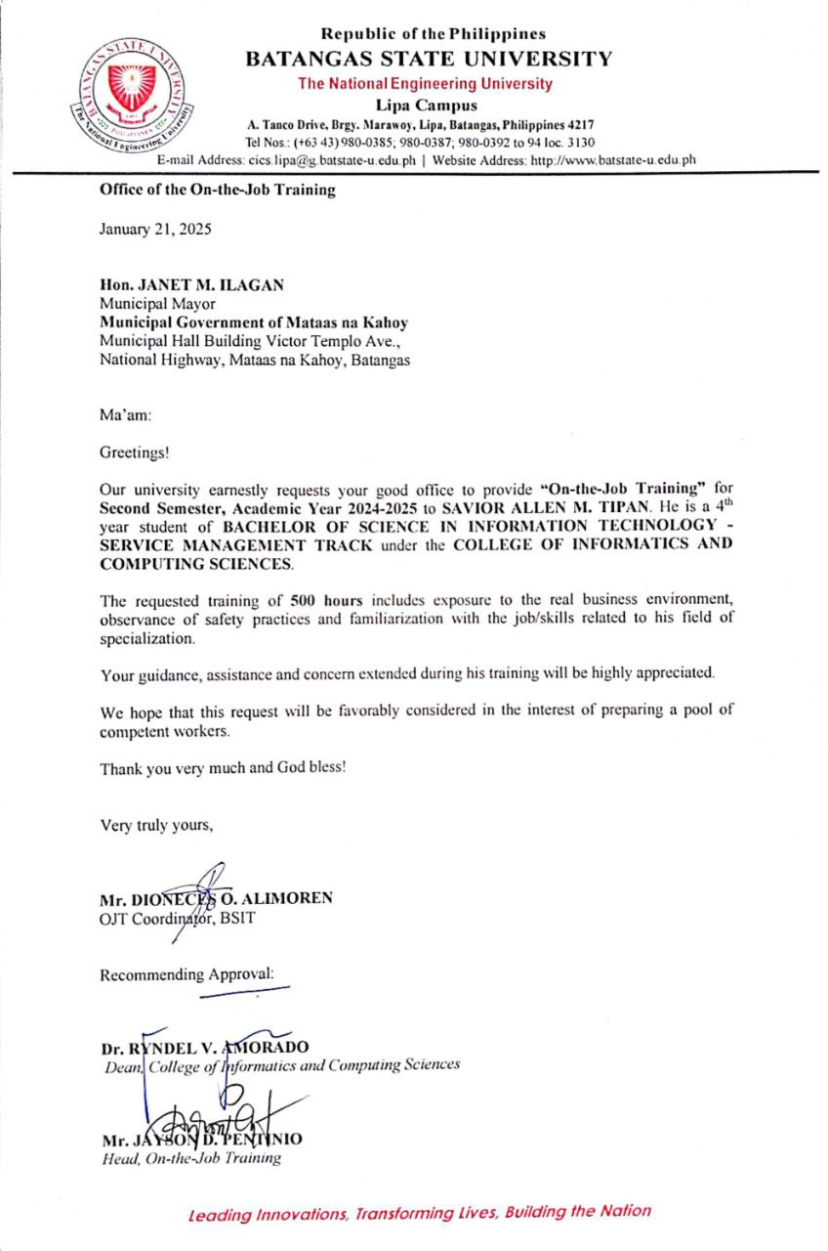

**Acceptance Form** 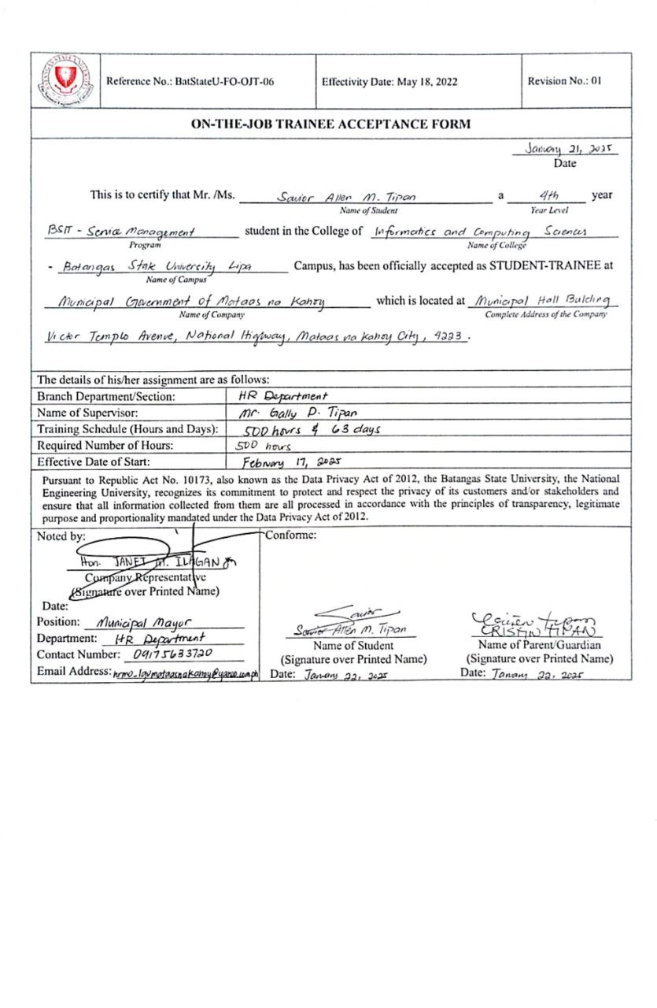

**Internship Training Agreement**

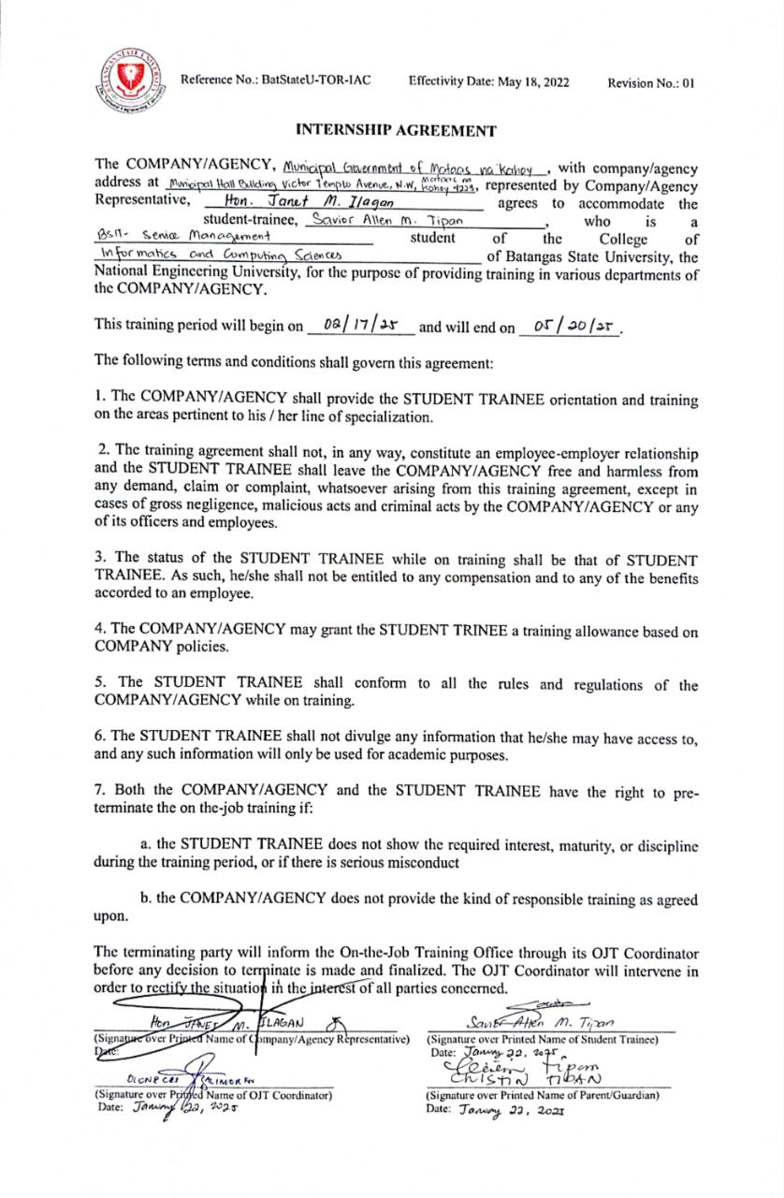

**Training Plan**

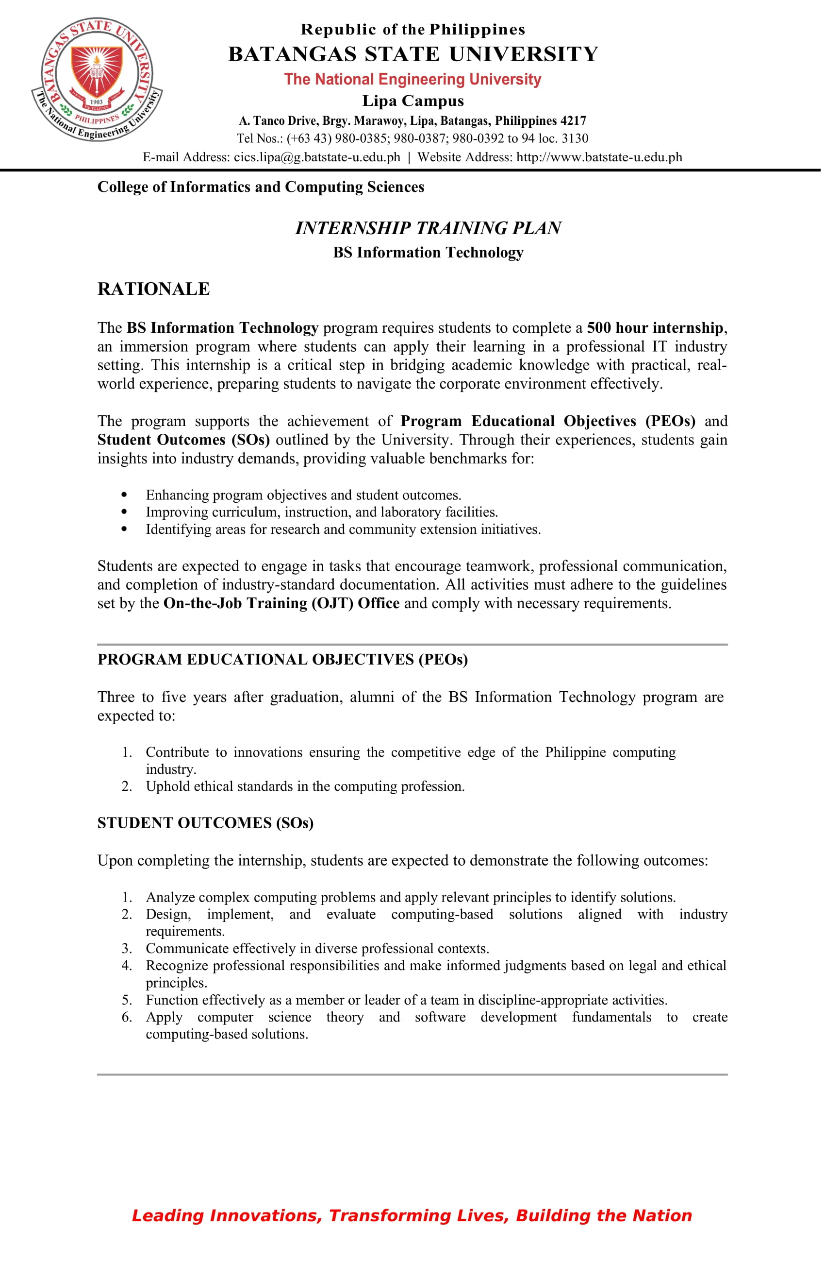

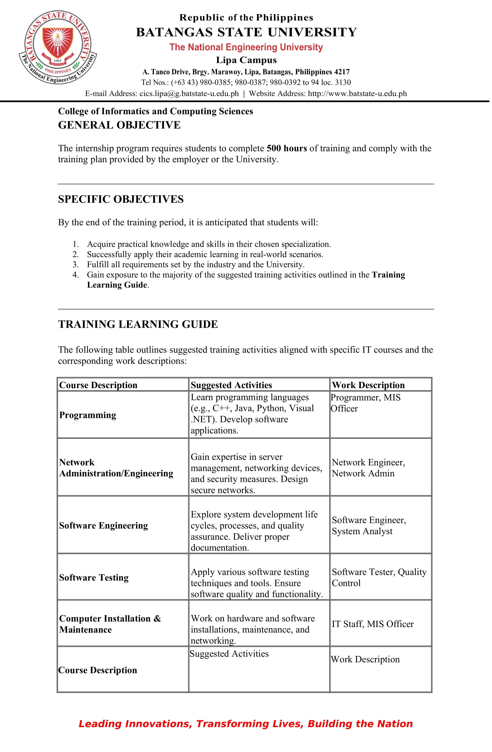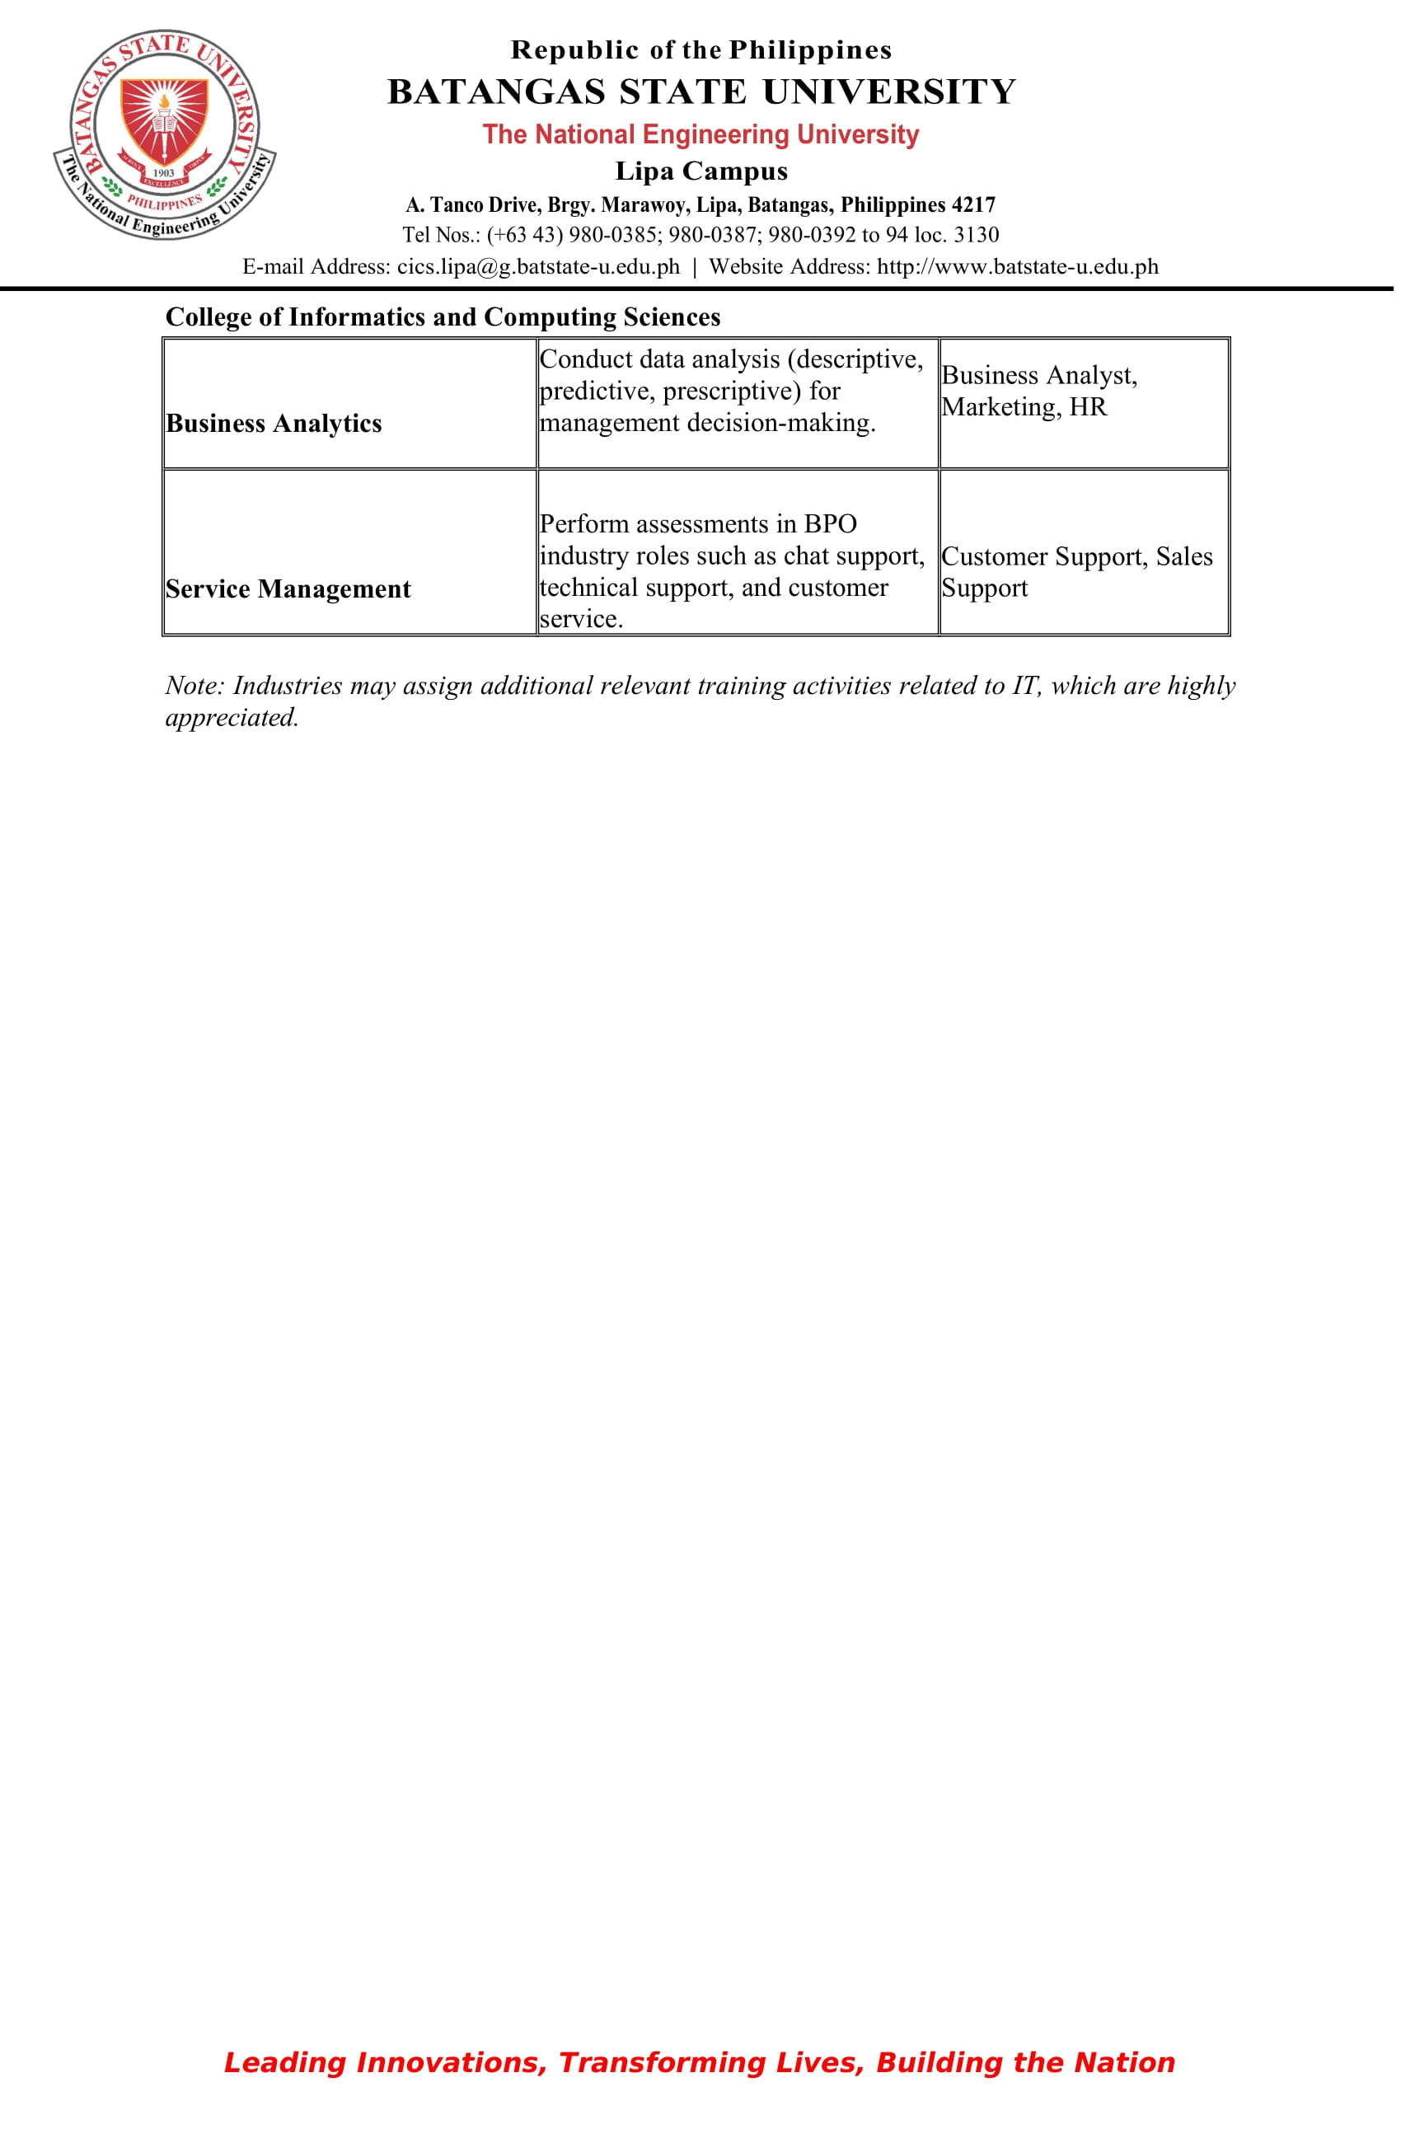

**Student-Trainee’s Personal History Statement**

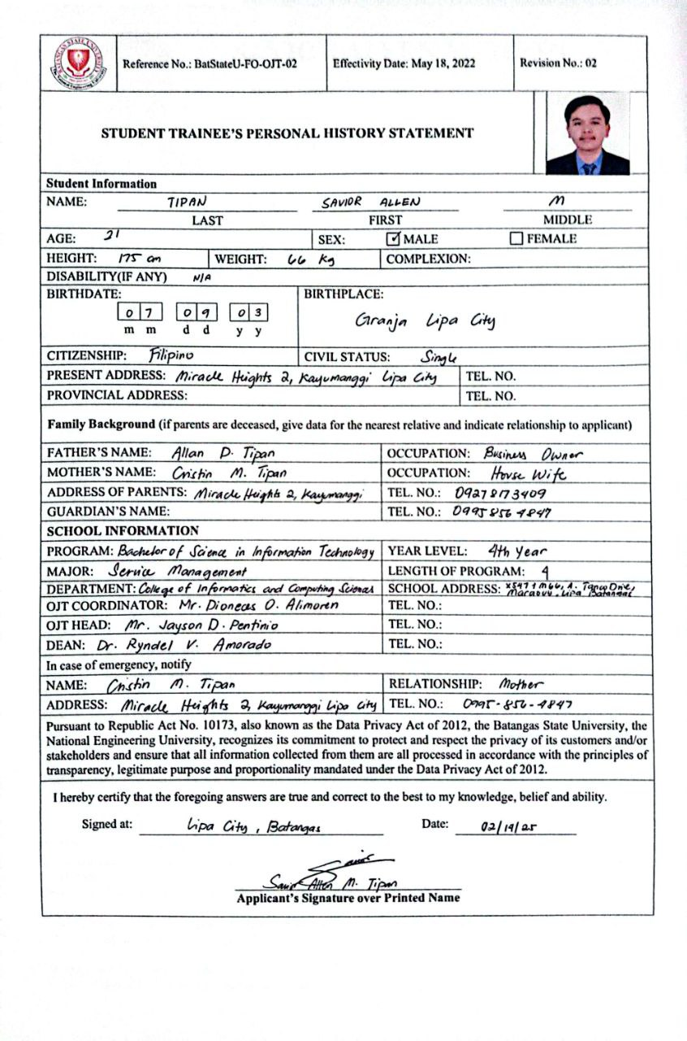

**Resume /Curriculum Vitae**

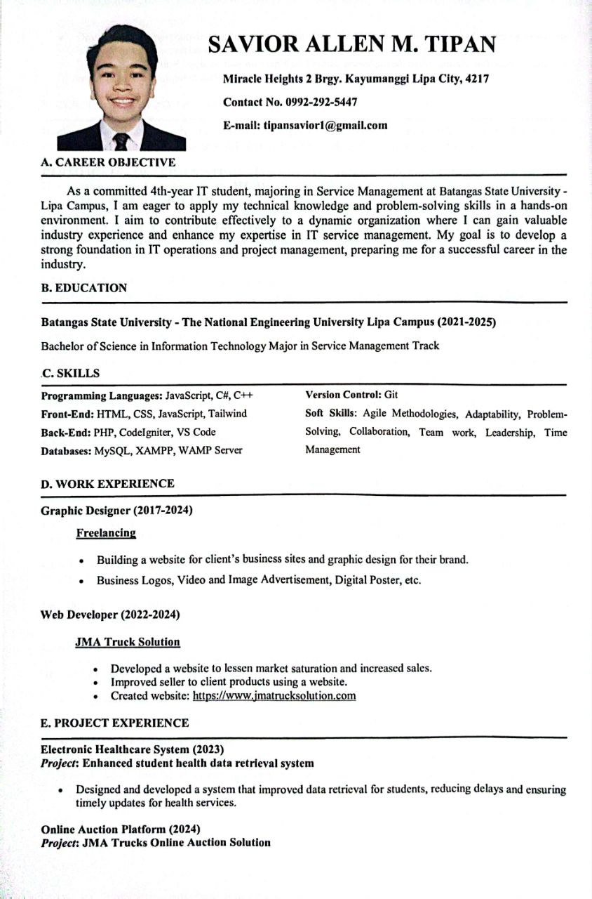

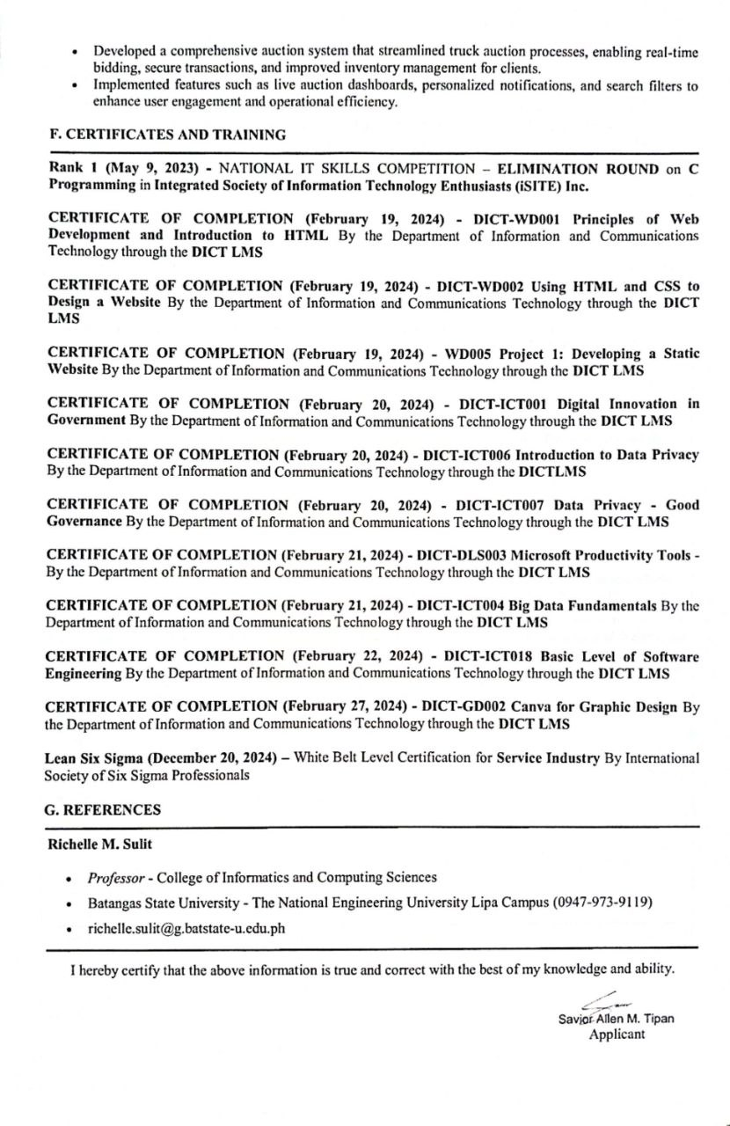

**Parent's Consent for Internship Training**

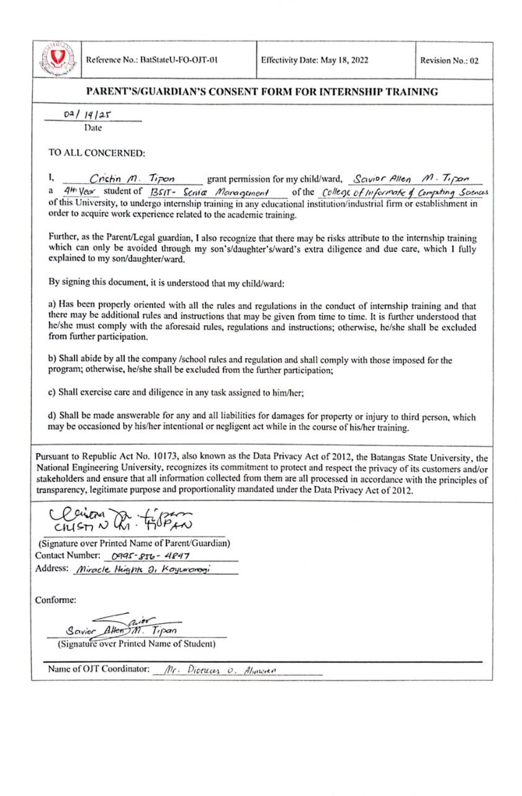

**Parent/Guardian's Valid ID**



**Registration Form**

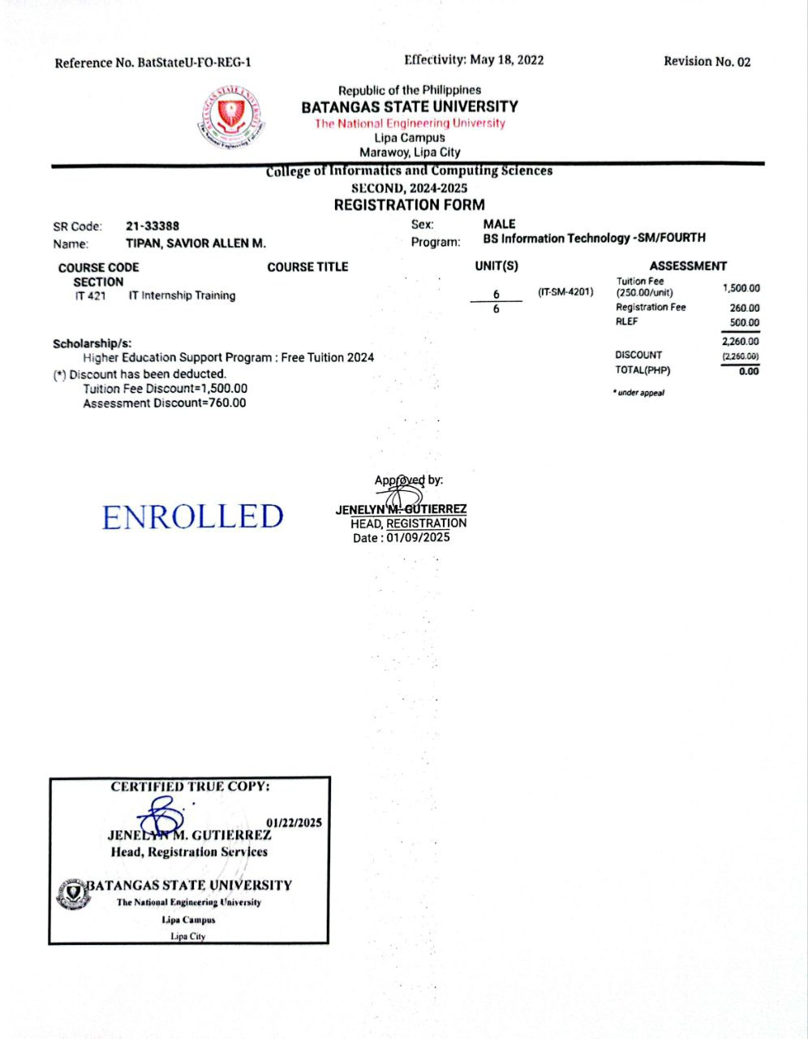

**OJT Time Frame**

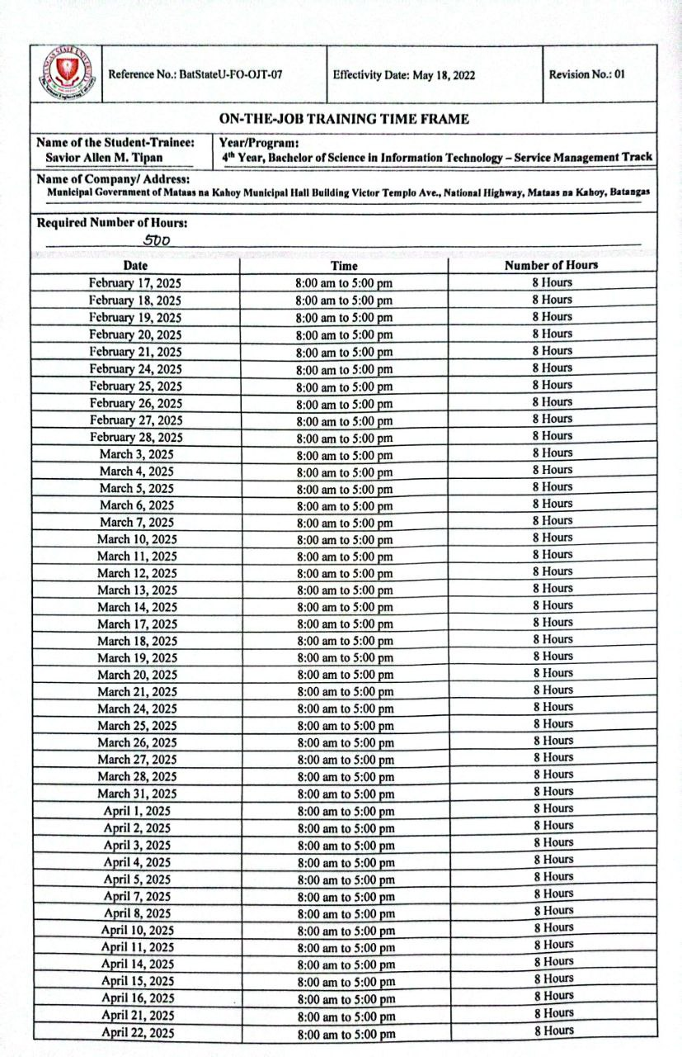

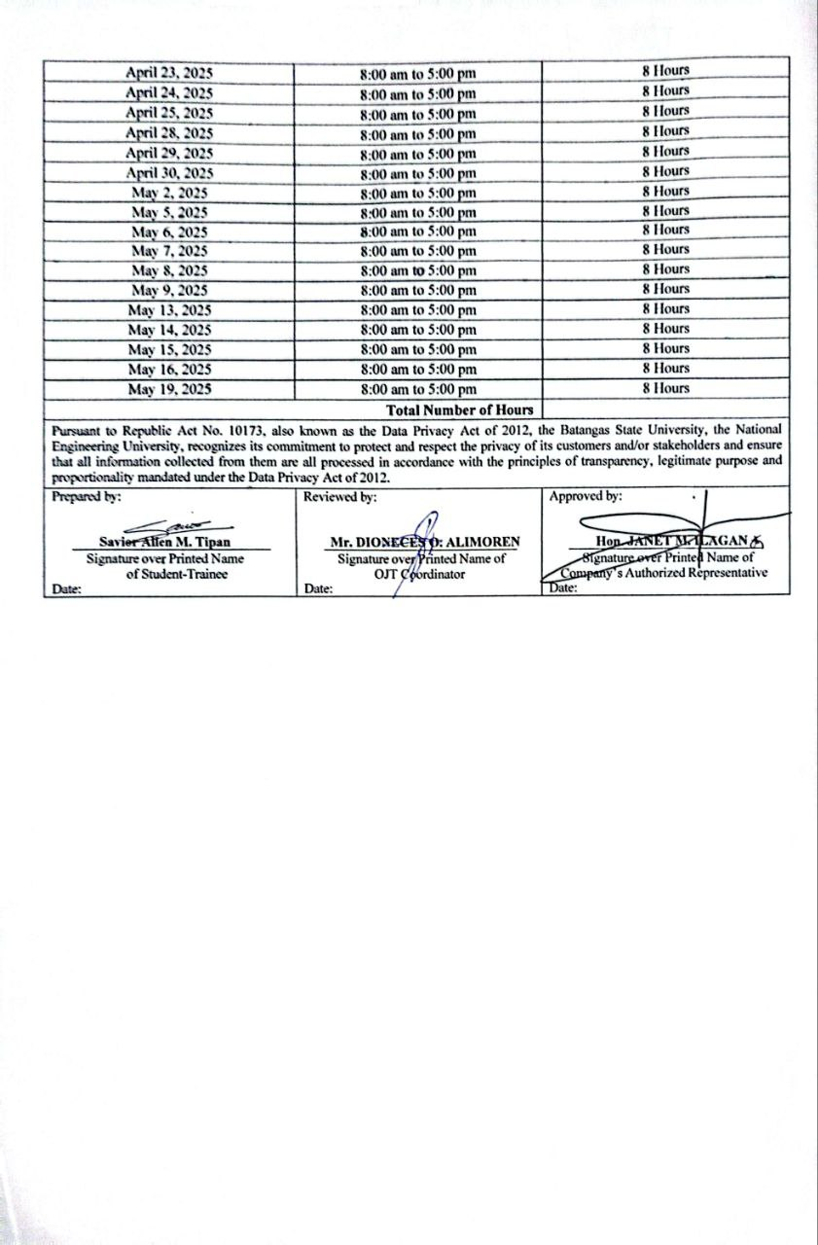

**Overtime Form** *(if applicable)*

**Location Map** *(applicable only to those who were deployed outside BatStateU)*

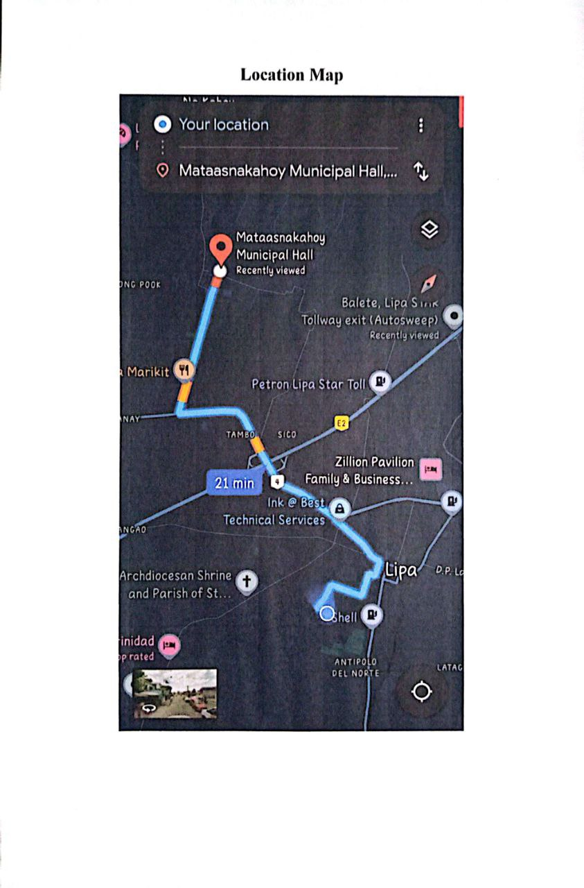

**Vaccine Card *(if applicable)***



**Pre-OJT Counseling Slip from the OGC**

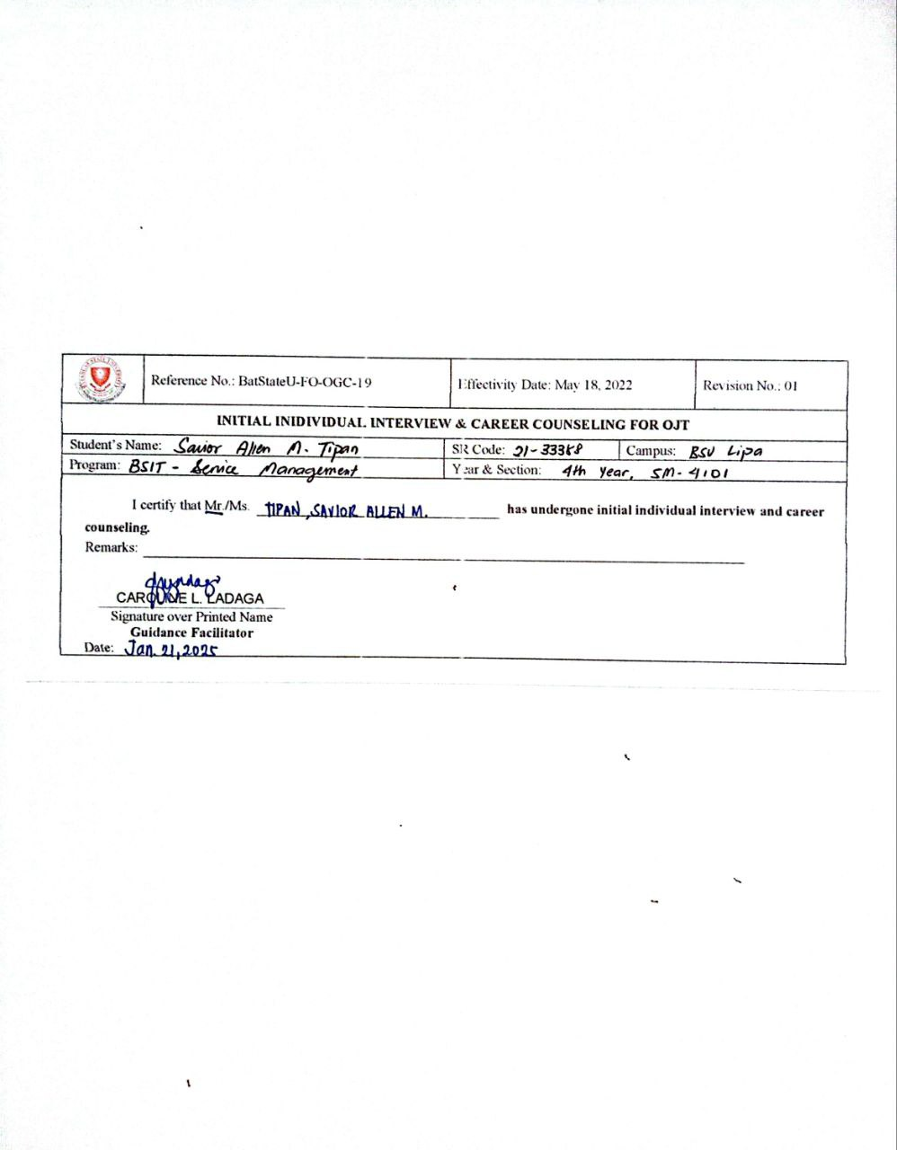

**Notarized Memorandum of Agreement (MOA)** 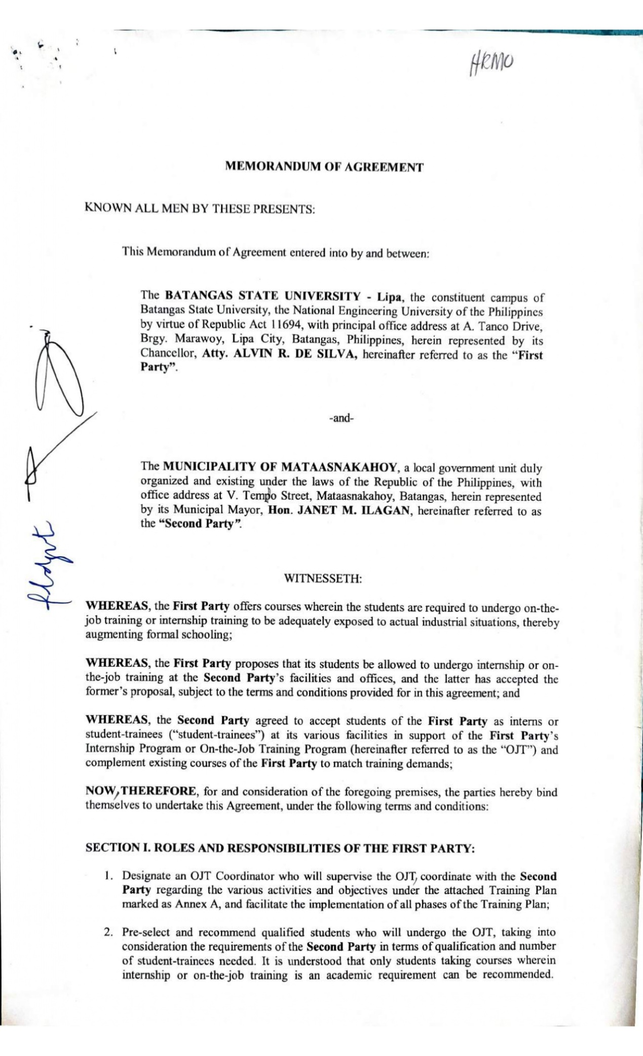

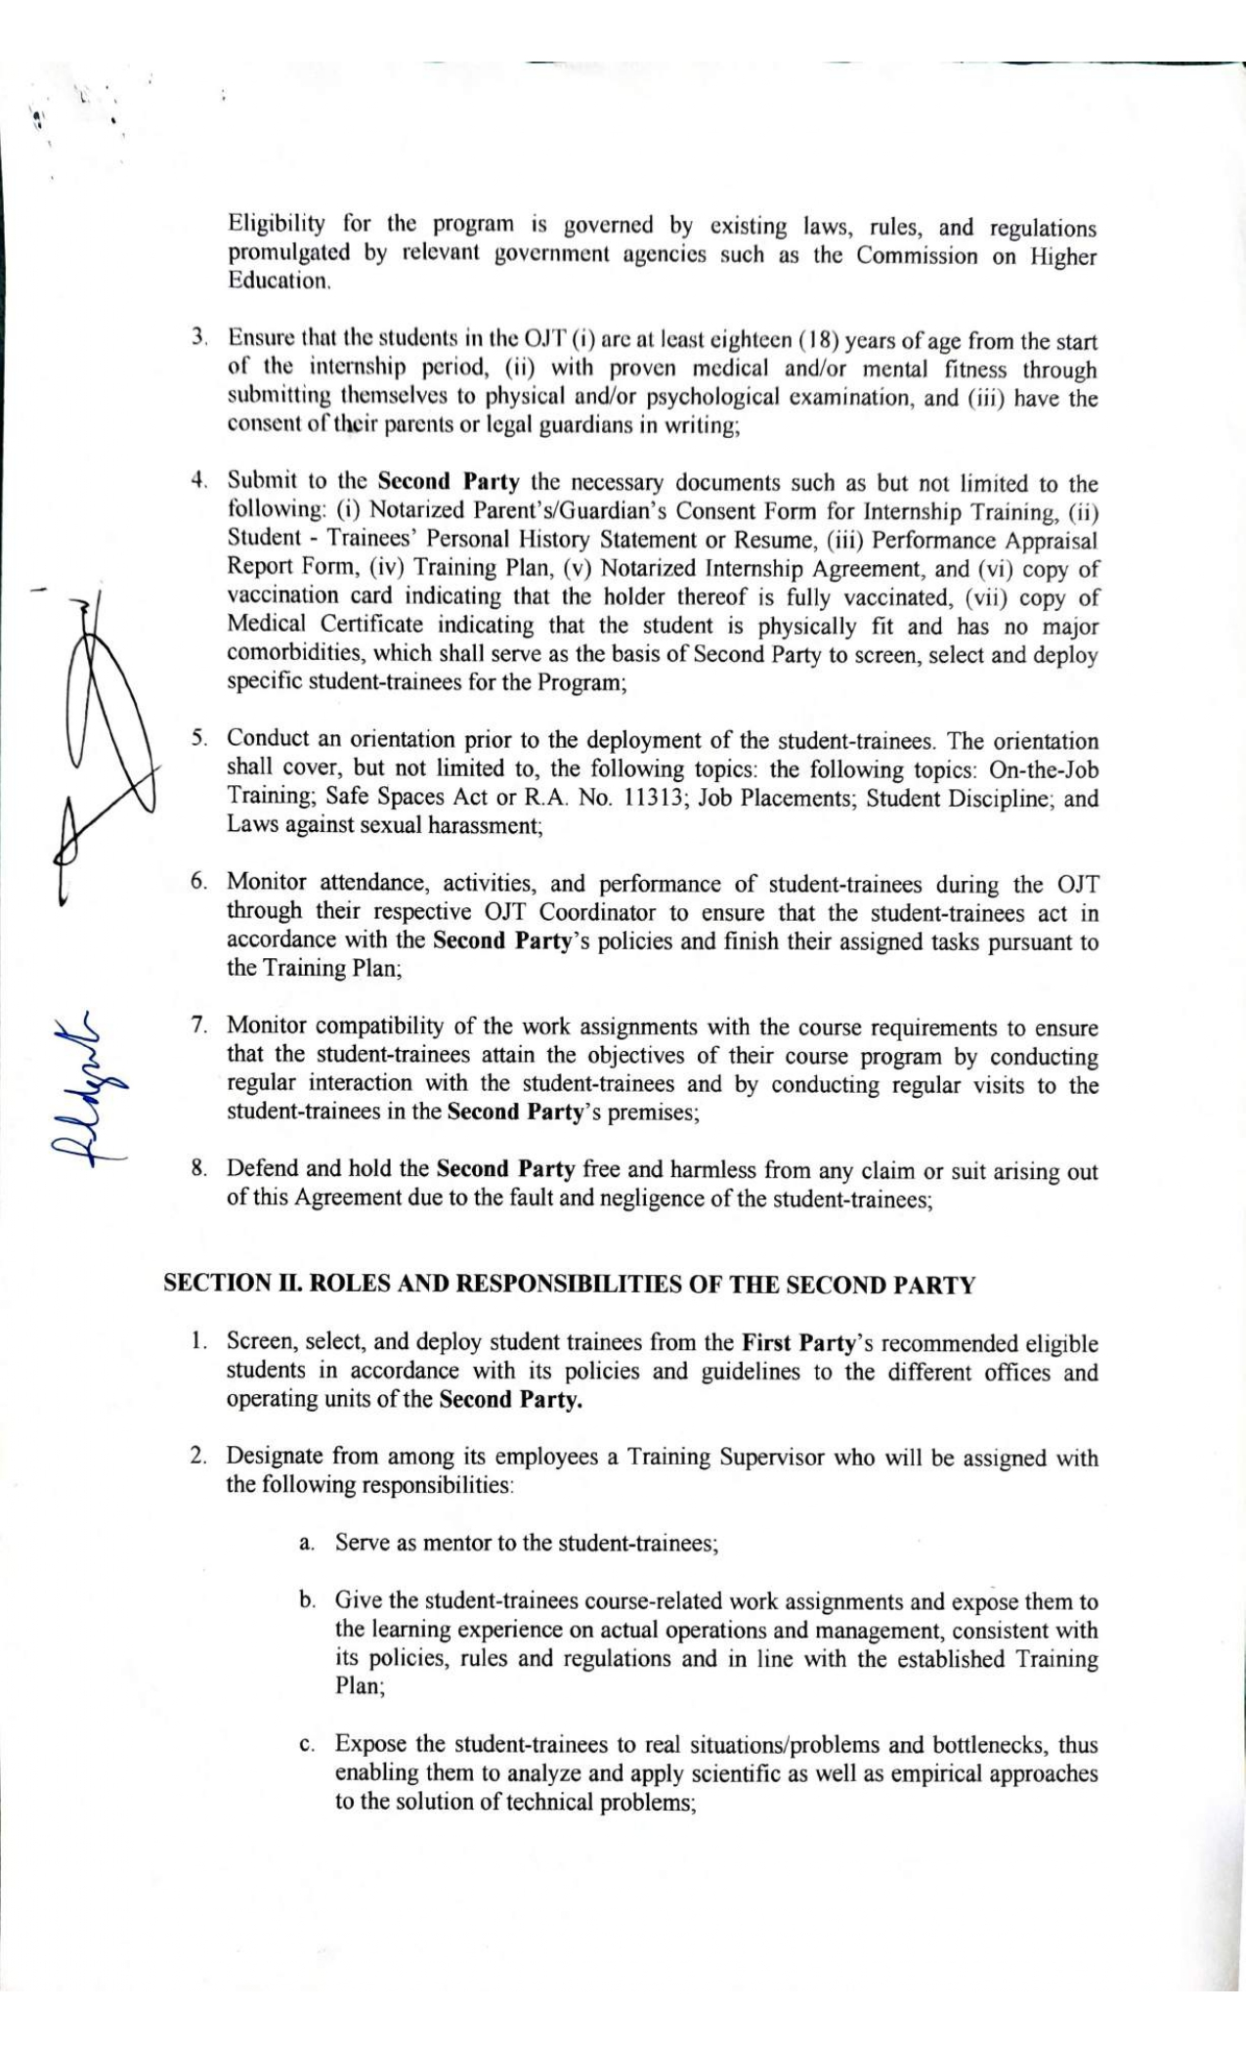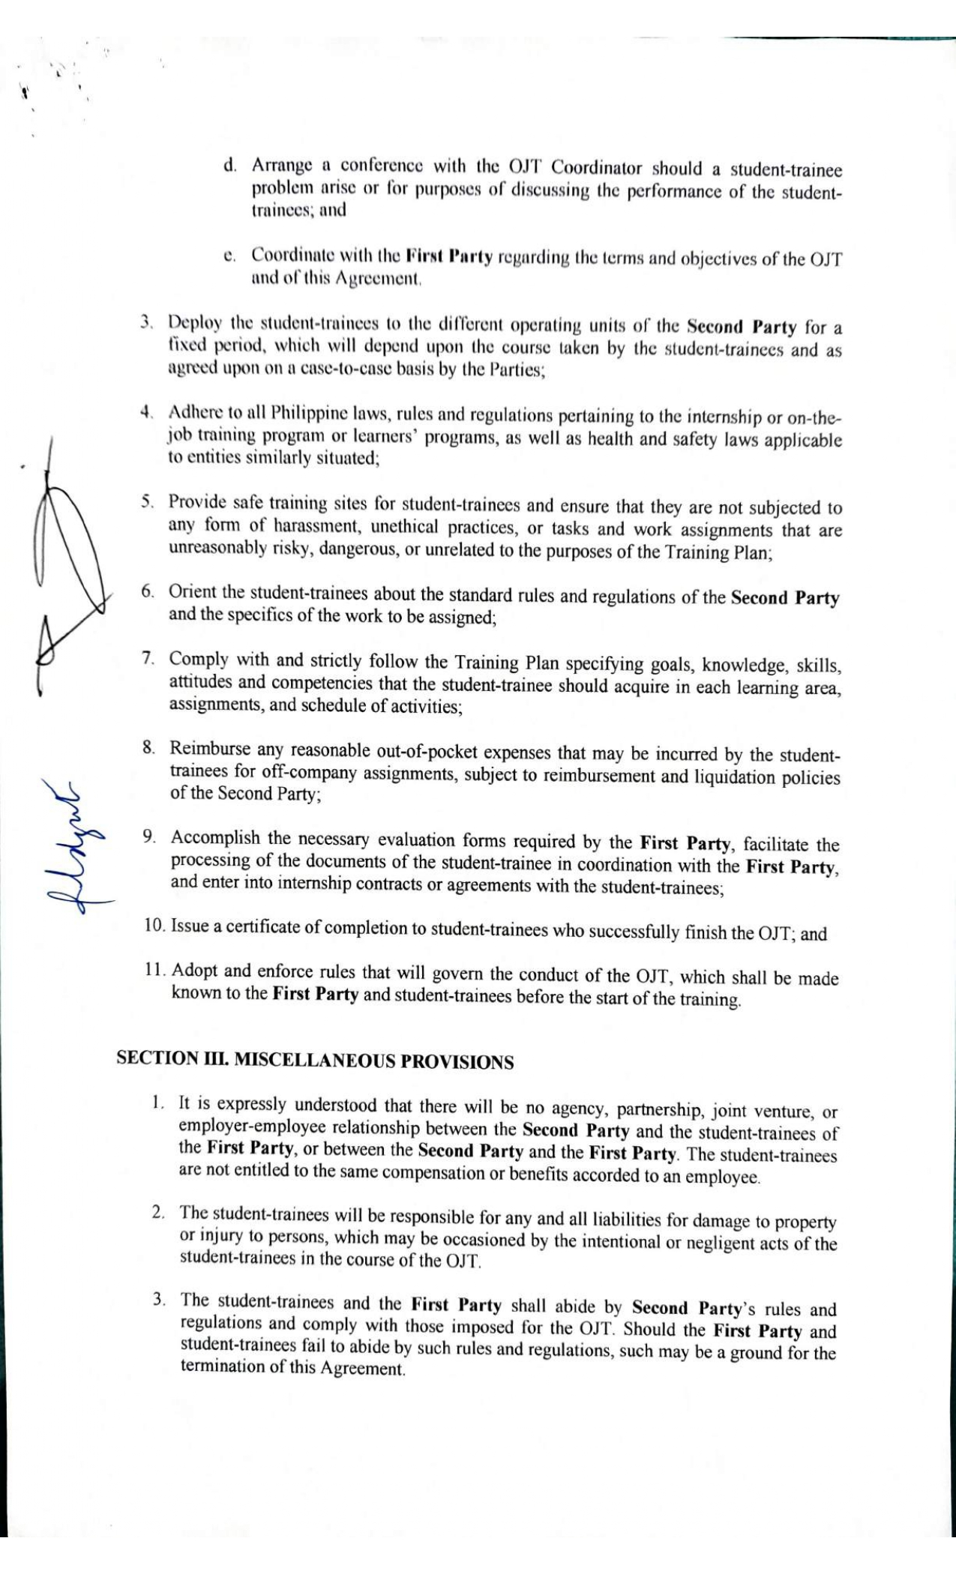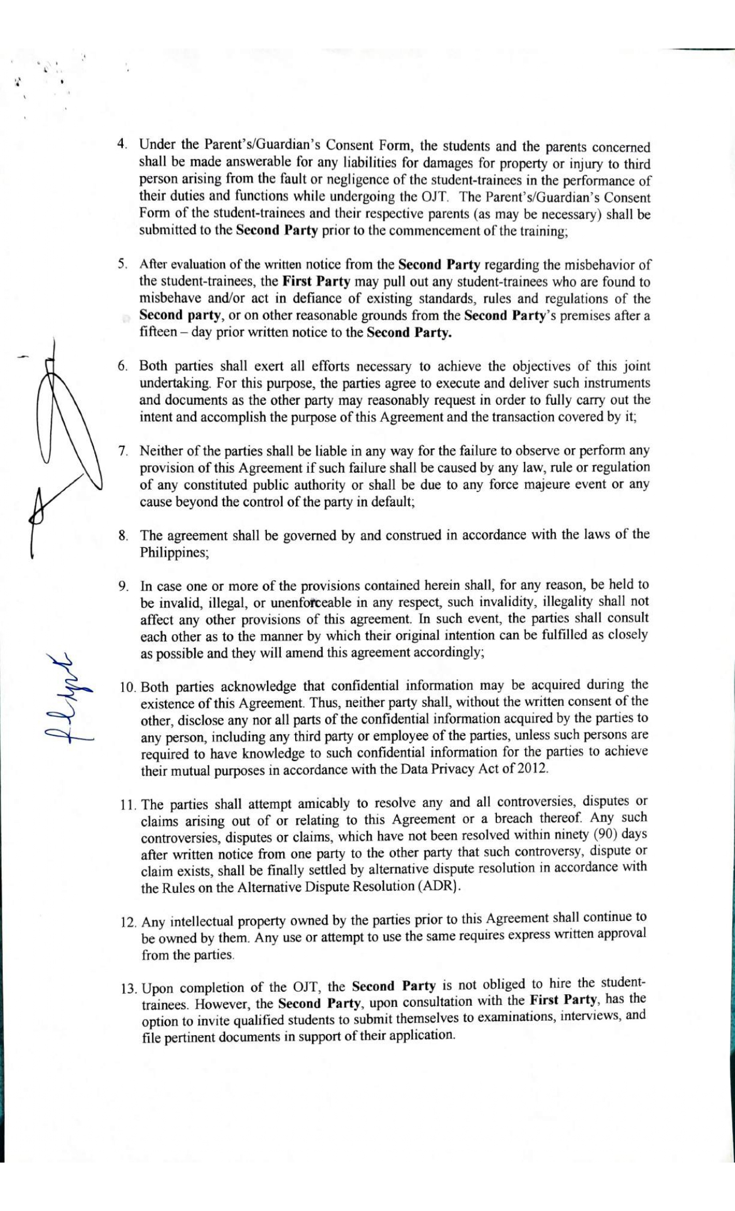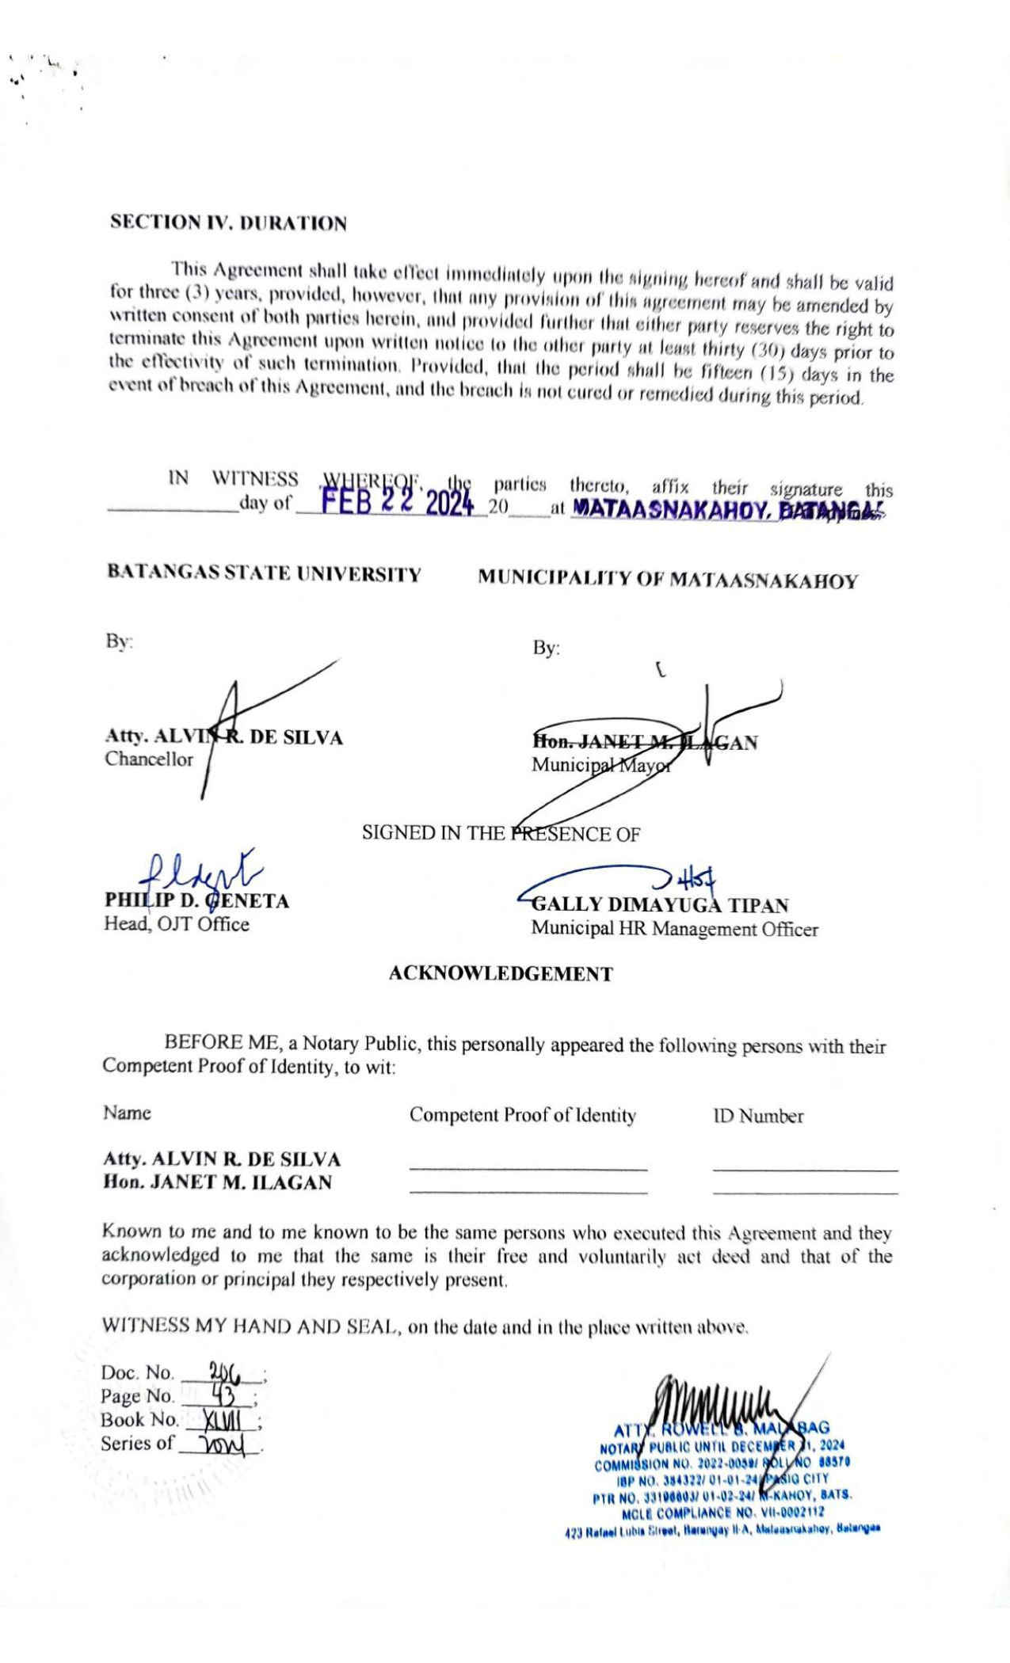

**Medical Certificate**

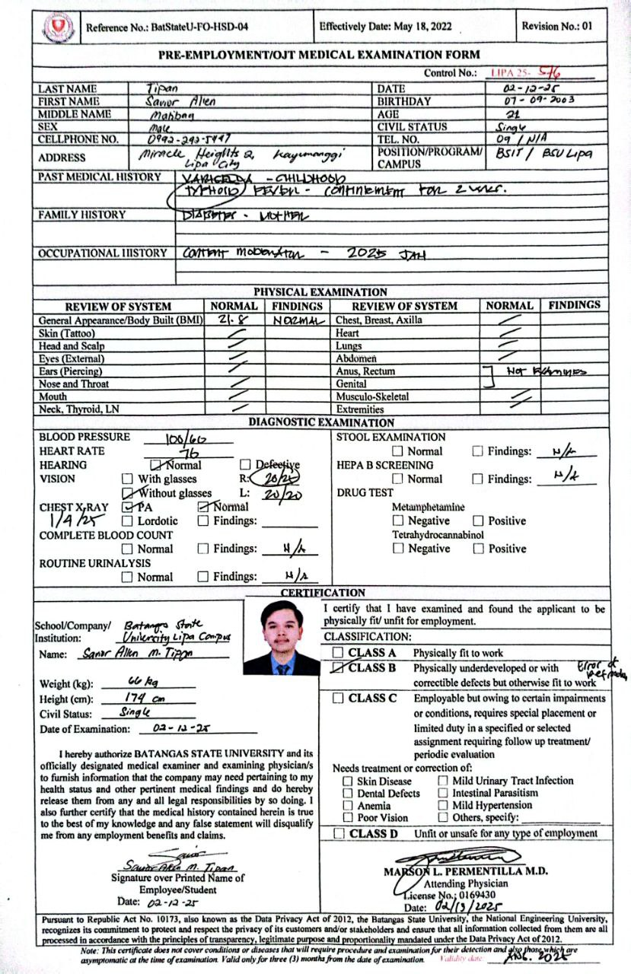

**Insurance**

**POST-OJT REQUIREMENTS**

1. **Student-Trainee’s Performance Appraisal Report**
2. **Training Supervisor’s Feedback Form**
3. **Student-Trainee’s Feedback Form**
4. **Post-OJT Counseling Slip**
5. **Certificate of Completion**
6. **Daily Time Record (DTR)/Attendance Log** *(if any)*